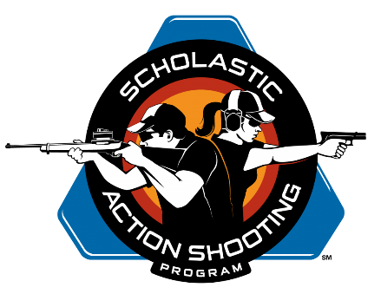

Request for SASP Age Waiver

The Scholastic Action Shooting Program (SASP) has guidelines that youth participation be allowed for grades 6 and above for the rimfire pistol discipline and grades 5 and above for the rifle discipline.

This is a formal request for a waiver for a youth in grade ________ that shows experience & abilities for that named youth to function in the SASP program in a manner consistent with guidelines and abilities for other Intermediate Division youth.

Youth Name Age Birth Date

Following is information relative to our waiver request with signatures by the parents making the waiver request. Also included is information from a NRA certified Pistol Instructor/SASP Coach coaching the identified youth that they have demonstrated mental and physical skills and maturity that is consistent with other Intermediate division youth that are allowed SASP participation.

Information from Parents regarding youth requesting waiver.

The named parent(s) below acknowledge;

1) Formally requesting a waiver for their child / youth in grade ____ to participate in SASP practices, coaching, and events.

2) Knowledge of their child that supports the youth’s mental & physical ability to participate in and adhere to standardized safety protocols for SASP practices and organized events.

3) Requests allowed participation in SASP coaching, practice, and organized events knowing and understanding that there are risks and dangers associated with the use of firearms; and, has reviewed related SASP information understanding the same risks and dangers with completion and endorsement of the formal SASP Consent & Waiver.

4) As the facility/range managers for the _________________________________ (facility), attests that the named youth has increased exposure to firearms utilization via their own supervision of the youth, as well as the youth also regularly observing, working and helping with shotgun & pistol facility operations, practices, and events.

_________________________________
Parent / Guardian Signature

_________________________________
Printed Name

_________________________________

_________________________________
Contact Info

Information from Certified NRA Pistol Instructor/SASP Head Coach relative to the youth requesting waiver.

_________________________________
Head Coach Signature

_________________________________
Printed Name

_________________________________

_________________________________
Contact Info

11/10/16

