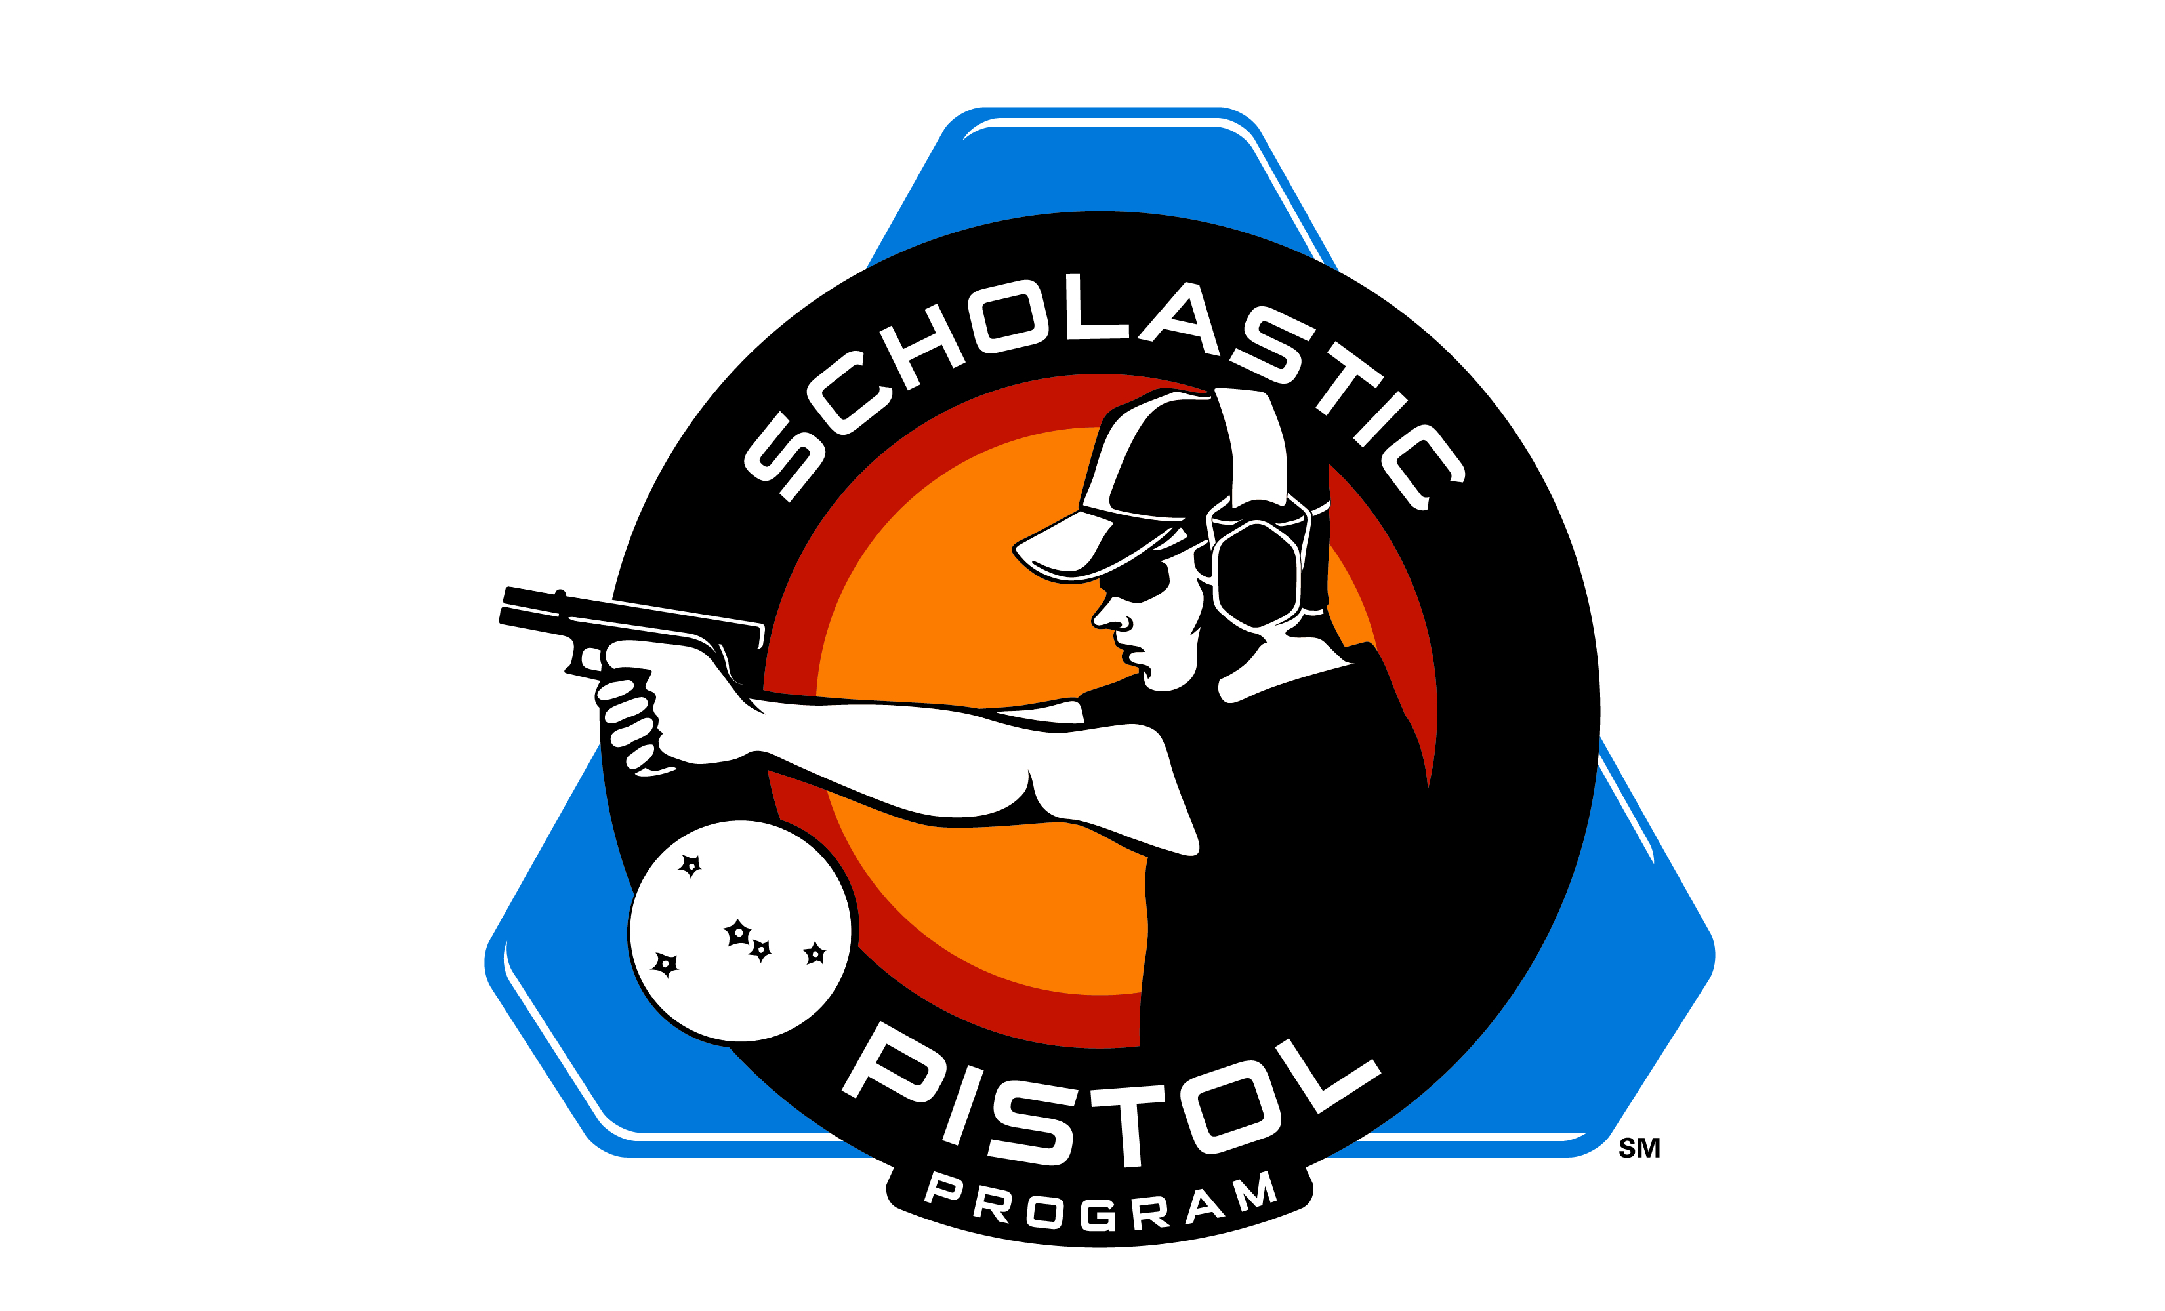

SPP/NRA/USA Shooting Level 1 Pistol Coaches School
September 13 and 14, 2014
Caledonia Sportsman’s Club
10721 Coldwater Avenue, SE
Alto, Michigan 49302

Pre-registration is required

The coach school is the heart of the coach education program. The instructors use up-to-date materials and PowerPoint presentations to present the discipline-specific coach course.

The registration fee includes a copy of the discipline-specific coach student study guide and other materials to help you with the details of coaching. Participants complete an open-book test as homework during the first evening of the course. The test is graded in class, reviewed for understanding, and then submitted to the NRA National Coach Trainer by the school instructor for credential processing. Upon successful completion of the coach school you will be a Coach (Level 1) (or Youth Trainer if under 18 years old) in that discipline. A Coach Credential Card is sent to the new coach. Please allow 6-8 weeks for processing.

What is taught in the school?

The coach school is two days of sports-specific lessons and practical coaching exercises designed to teach the coach candidate the basics of coaching. The following general subjects are taught:

- Introduction to the Coaching Program
- Safety and Risk Management
- Competition Events
- Rulebook Use
- Equipment and Facilities
- Fundamentals of Shooting
- Coaching Ethics
- Coaching Methodology
- Sports Psychology
- Training Planning
- Running Quality Programs
- How to Conduct Tournament

The Level 1 pistol coach’s course through the National Rifle Association, USA Shooting, and the Scholastic Pistol Program covers all required coaching fundamentals for pistol coaches in the Scholastic Shooting Sports Foundation’s Scholastic Pistol Program (SPP) in addition to other disciplines of pistol competition. The training is provided by the SPP/NRA/USAS National Coach Development Staff (NCDS). The course duration is 2 days with class running from 8:00 a.m. to 5:00 p.m. each day. Candidates should bring eye and ear protection and note-taking materials with them along with either a 9mm or .22 lr handgun and 50 rounds of ammunition for their handgun.

The cost of the course is $140 which includes all printed materials, 3 year coaching credentials with the NRA, a binder for your materials, and lunch/refreshments each day.

Pre-registration by check or credit card is required using the form below. Make checks payable to the Scholastic Shooting Sports Foundation.

Full Name:

Address:

City: State: Zip Code:

Cell/Daytime Phone:

Email:

Credit Card (Visa, MasterCard, Discover):

Card Number: Expiration Date:

Card (3 digit security code):

Mail Completed Form to:

Tammy Mowry
SPP Program Manager
288 Crisswell Road
Butler, PA 16002
(724) 822-7390

If paying by credit card, you may also scan and email your application to: tmowry@sssfonline.com

