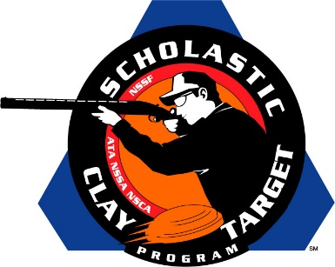

Ohio’s Buckeye Chippewa Trapshooting Club Takes Varsity Trap National Title

SAN ANTONIO, Texas – With the top score of all teams competing in American Trap, the Buckeye Chippewa Trapshooting Club of Ohio won the Varsity Division title in the American Trap competition at the Scholastic Clay Target Program (SCTP) National Team Championships breaking 982 of 1,000 targets.

Austin Jacob of Copley led the Buckeye Chippewa team with 198, followed by Hunter Drerup (Chippewa Lake) with 197, Nolan Loughry (Hudson) with 197, Michael Adkins (Rittman) with 196 and Chase Jindra (Spencer) with 194.

Held July 13-18 at the World Shooting and Recreational Complex in Sparta, Illinois, 2,466 athletes faced over 872,500 clay targets during six days of competition in the shooting disciplines for Trap, Skeet and Sporting Clays.

Second place went to Team Henges of Missouri with 977. Nicholas Koury of Manchester led with 197 followed by Anthony Simon (Ballwin) with 196, Jack Koury (Manchester) with 196, Kyle Lazarski (Saint Louis) with 195 and Max Weiser (Town & Country) with 193.

Another Missouri squad, the Branson Trap Team, finished third with 974 and each shooter breaking over 190 targets. Kennedy Mattox (Branson) broke 199, followed by Colten Calvert (Branson) with 196, Jacob Anderson (Branson) with 195, Kory Gray (Branson) with 192 and Gage Dixon (Omaha, Ark.) with 192.

Rounding out the top five were a pair of Burlington (Wisc.) High School Demons Shooting Team squads. The fourth place squad of Weston Uhlenhake (Burlington) with 196, Zachary Hahn (Burlington) with 195, Hunter Conrad (Bristol) with 195, Jarod Hahn (Burlington) with 191 and Kaylee Lancour (Burlington) with 190 finished with a 967 total.

Just four targets back in fifth with 963 was the B.H.S. squad of Cody Kreuscher (Waterford) with 198, Cullen Kruser (Burlington) with 194, Brian Morris (Burlington) with 194, Boone Bubner (Burlington) with 191 and Tyler Regner (Burlington) with 186.

The Scholastic Clay Target Program (SCTP) is a youth development program in which adult coaches and other volunteers use the shooting sports of Trap, Skeet and Sporting Clays, as well as the Olympic disciplines of Bunker Trap, Trap Doubles and International Skeet to teach and to demonstrate sportsmanship, responsibility, honesty, ethics, integrity, teamwork, and other positive life skills.

The Scholastic Shooting Sports Foundation, Inc. (SSSF), a 501(c)(3) nonprofit organization, is the National Governing Body for the Scholastic Clay Target Program. SCTP was started by the National Shooting Sports Foundation in 2001.

For more information about SCTP and SSSF, visit www.sssfonline.org. You can also follow SCTP on Facebook at www.facebook.com/ShootSCTP.

