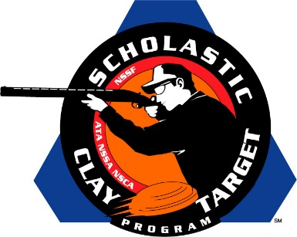

Top Guns For Men’s And Women’s American Trap Named At SCTP Nationals

SAN ANTONIO, Texas – The top male and female athletes in American Trap were recognized by the Scholastic Clay Target Program (SCTP) at the 2015 National Team Championships for their outstanding individual performances in each of its six competitive divisions.

Honored for their ability to break clay targets on the Trap fields at the SCTP Nationals were women shooters Ella Kurrus (Kirkwood, Mo.) of Team Henges in the Rookie Division with 179; Grace Marlen (Freeburg, Ill.) of the Delta Waterfowl Arch Chapter Clay Busters in the Intermediate/Entry Level Division with 189; Jessica Strasser (Waterford, Wisc.) of the Waterford Wolverine Shooting Team in the Intermediate/Advanced Division with 196; Alexis Eidson (Byron, Ga.) of the Brookline Top Shots in the Junior Varsity Division with 193; Makayla Boisseau (Adams, Tenn.) of the Southern Shooting Sports in the Varsity Division with 197; and Stephanie Beardsley (Glen Rock, Pa.) of the Emmanuel College Clay Target Shooting in the Collegiate Division with 196.

Among the men competing this year the top performances came from Ty Zimmer (Bunker Hill, Ill.) of the Brittany Youth Club in the Rookie Division with 186; Dylan Wester (Brooklyn Heights, Ohio) of the Buckeye Chippewa Trapshooting Club in the Intermediate/Entry Level Division with 189; Shane Marshall (Medina, Ohio) of the Buckeye Chippewa Trapshooting Club in the Intermediate/Advanced Division with 198; Zachary S Koehler (Brownstown, Ill.) of the Tri County QUGA Clay Grinders in the Junior Varsity Division with 199; Houston Carson (Drummonds, Tenn.) of the T-County Clay Busters in the Varsity Division with 200; and Jordan Hintz (Burlington, Wisc.) of the B.H.S. Demons Shooting Team in the Collegiate Division with 200.

Held July 13-18 at the World Shooting and Recreational Complex in Sparta, Illinois, 2,466 athletes faced over 872,500 clay targets during six days of competition in the shooting disciplines for Trap, Skeet and Sporting Clays.

The Scholastic Clay Target Program (SCTP) is a youth development program in which adult coaches and other volunteers use the shooting sports of Trap, Skeet and Sporting Clays, as well as the Olympic disciplines of Bunker Trap, Trap Doubles and International Skeet to teach and to demonstrate sportsmanship, responsibility, honesty, ethics, integrity, teamwork, and other positive life skills.

The Scholastic Shooting Sports Foundation, Inc. (SSSF), a 501(c)(3) nonprofit organization, is the National Governing Body for the Scholastic Clay Target Program. SCTP was started by the National Shooting Sports Foundation in 2001.

For more information about SCTP and SSSF, visit www.sssfonline.org. You can also follow SCTP on Facebook at www.facebook.com/ShootSCTP.

