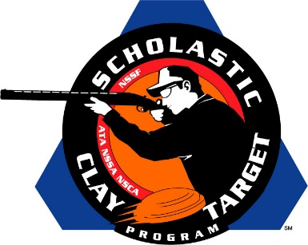

Golden Eagle (Ill.) Delivers Rookie Division 1-2 Punch At American Trap Nationals

SAN ANTONIO, Texas – Golden Eagle (Illinois) shooting team athletes delivered a one-two punch at the Scholastic Clay Target Program (SCTP) National Team Championships by taking the top two spots, and the Rookie Division National Title, in American Trap.

Held July 13-18 at the World Shooting and Recreational Complex in Sparta, Illinois, 2,466 athletes faced over 872,500 clay targets during six days of competition in the shooting disciplines for Trap, Skeet and Sporting Clays.

Landon Sievers (Batchtown) led the national champs breaking 186 of his 200 targets. Teammates Cole Bick (O’Fallon, Mo.) with 185, Kyle Robeen (Hardin) with 173, Payson Camerer (Golden Eagle) with 173 and Samuel Gilman (Hardin) with 167, helped give the team a title winning total of 884 targets.

With a final target total of 816, the second place Golden Eagle squad was led by Joe Stein (Hardin) with 178 followed by August Squier (Hamburg) with 169, Luke Wickenhauser (Michael) with 165, Hunter Roth (Hardin) with 159 and Bryce Clayton (Winchester) with 145.

The Carlinville Clay Busters, another Illinois team, finished third with 798, and was led by Dane Bouillon (Carlinville) with 169, followed by Gavin Rynders (Greenfield) with 167, Hank Rhodes (Divernon) with 164, Brody Harris (Carlinville) with 152 and Seth Reno (Medora) with 146.

The Henry County No Fly Zone of Tennessee, the only team not from Illinois to make it to the awards podium, finished fourth wit 746 targets. Will Overton of Paris led the No Fly Zone with 163 followed by Dalton Dodd (Paris) with 154, Wade Tucker (Buchanan) with 148, Evan Bevill (Buchanan) with 146 and Parker Dyche (Buchanan) with 135.

The Brittany Youth Club rounded out the top five with 709. Led by Ty Zimmer (Bunker Hill) with 186, the Illinois squad saw strong performances from Samantha Schnefke (New Douglas) with 161, Lane Jones (Jerseyville) with 130, Caiden Anthony (Falto) with 117 and Danyn Moore (Medora) with 115.

The Scholastic Clay Target Program (SCTP) is a youth development program in which adult coaches and other volunteers use the shooting sports of Trap, Skeet and Sporting Clays, as well as the Olympic disciplines of Bunker Trap, Trap Doubles and International Skeet to teach and to demonstrate sportsmanship, responsibility, honesty, ethics, integrity, teamwork, and other positive life skills.

The Scholastic Shooting Sports Foundation, Inc. (SSSF), a 501(c)(3) nonprofit organization, is the National Governing Body for the Scholastic Clay Target Program. SCTP was started by the National Shooting Sports Foundation in 2001.

For more information about SCTP and SSSF, visit www.sssfonline.org. You can also follow SCTP on Facebook at www.facebook.com/ShootSCTP.

