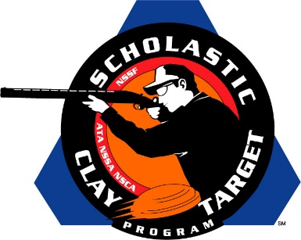

South Gibson (Tenn.) Hornets Swarm To Junior Varsity Trap National Title

SAN ANTONIO, Texas – The Hornets of South Gibson County High School in Tennessee broke 945 of 1,000 targets to win the Junior Varsity Division title in the American Trap competition at the Scholastic Clay Target Program (SCTP) National Team Championships.

Drew Smith of Humboldt led the Hornets to the title with 193 targets followed by Connor Warren (Milan) with 191, Cameron Penderton (Medina) with 188, Reed Watt (Medina) with 187 and Garrison Curtis (Humbolt) with 186.

Held July 13-18 at the World Shooting and Recreational Complex in Sparta, Illinois, 2,466 athletes faced over 872,500 clay targets during six days of competition in the shooting disciplines for Trap, Skeet and Sporting Clays.

The second of three squads from the Volunteer State to make it to the awards podium was the Richland Trap & Sporting Clays team. Led by Gus Mcgowan (Lynnville) with 193, teammates Bobby Sowell (Pulaski) with 190, Dillon Clark (Pulaski) with 187, Jesse Thorpe (Cornersville) with 185 and Gaige Lane (Pulaski) with 183, combined for a second place finish of 938 targets.

Missouri’s Gateway Gun Club Youth Shooters placed third with 937 targets and was led by Trey Stephens (St. Charles) with 193 followed by Jake Hoffman (St. Charles) with 191, Mitchell Box (St. Charles) with 189, Connor Cross (O'Fallon) with 184 and Matthew Meyer (St. Charles) with 180.

The Keystone State’s Warren County Claybusters from Pennsylvania took fourth. Logan Muir (Corry) with 193, Tagen Dingfelder (Elgin) with 190, Dillon Cross (Corry) with 186, Michael Dietz (Corry) with 186 and Jonah Fronk (Corry) with 178 combined for 933 broken clays.

Rounding out the top five was the last of the Tennessee teams, the Cumberland County Clay Crushers, who broke 926 targets. David Weismuller of Oakdale led the way with 193, followed by Jordan Burgess (Crossville) with 192, Hunter Webb (Crossville) with 185, Ryley Phillips (Crossville) with 182 and Cooper Wyatt (Crossville) with 174.

The Scholastic Clay Target Program (SCTP) is a youth development program in which adult coaches and other volunteers use the shooting sports of Trap, Skeet and Sporting Clays, as well as the Olympic disciplines of Bunker Trap, Trap Doubles and International Skeet to teach and to demonstrate sportsmanship, responsibility, honesty, ethics, integrity, teamwork, and other positive life skills.

The Scholastic Shooting Sports Foundation, Inc. (SSSF), a 501(c)(3) nonprofit organization, is the National Governing Body for the Scholastic Clay Target Program. SCTP was started by the National Shooting Sports Foundation in 2001.

For more information about SCTP and SSSF, visit www.sssfonline.org. You can also follow SCTP on Facebook at www.facebook.com/ShootSCTP.

