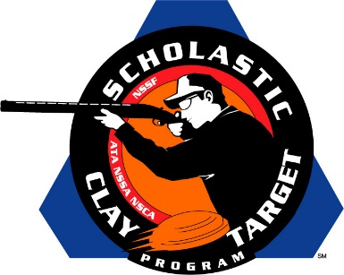

Michigan’s Fudd Dusters Take Home Intermediate/Entry Level Division Trap National Title

SAN ANTONIO, Texas – When the Fudd Dusters returned to home Michigan after the Scholastic Clay Target Program (SCTP) National Team Championships it wasn’t empty handed as the five member squad broke 905 of their 1,000 targets to win the American Trap Nationals in the Intermediate/Entry Level Division.

Held July 13-18 at the World Shooting and Recreational Complex in Sparta, Illinois, 2,466 athletes faced over 872,500 clay targets during six days of competition in the shooting disciplines for Trap, Skeet and Sporting Clays.

Tristan Schroder of Battle Creek led the Fudd Dusters with 187 targets followed by Andrew Vanmiddlesworth (Climax) with 182, Seith Miller (Albion) with 182, Jackson Schroder (Battle Creek) with 178 and Bryson Faulk (East Leroy) with 176.

Second place went to the Carlinville Clay Busters of Illinois where Bradley Rynders (Greenfield) with 188, Hayden Vetter (Greenfield) with 181, Keaton Whalen (Virden) with 174,
Brady Cox (Carrollton) with 173 and David Hutchison (Waverly) with 172 came together for a final 888 target total.

A pair of Missouri teams finished third and fourth. The Branson Trap Team broke 866 targets and was led by Brandon Pickens (Branson) with 187 followed by Rae Woods (Reeds Spring) with 185, Alyssa King (Walnut Shade) with 173, Zachary Wallace (Branson) with 162 and Justin Bailey (Walnut Shade) with 159.

The Wildcat Trap squad’s Chase Perry (Rogersville) with 185, James Grant Boswell (Rogersville) with 179, Hadley Ewing (Rogersville) with 174, Hunter Dedmon (Rogersville) with 174 and Lilly Valdez (Rogersville) with 152 combined for a total of 864.

Rounding out the top five with 863 was the Little Ankeny Jaguars Trap Team from Iowa. Chase Martin (Ankeny) led with 181 followed by Hunter Block (Ankeny) with 178, Kael Richmond (Ankeny) with 176, Joshua Jorgensen (Ankeny) with 174 and Benny Schaefer (Ankeny) with 154.

The Scholastic Clay Target Program (SCTP) is a youth development program in which adult coaches and other volunteers use the shooting sports of Trap, Skeet and Sporting Clays, as well as the Olympic disciplines of Bunker Trap, Trap Doubles and International Skeet to teach and to demonstrate sportsmanship, responsibility, honesty, ethics, integrity, teamwork, and other positive life skills.

The Scholastic Shooting Sports Foundation, Inc. (SSSF), a 501(c)(3) nonprofit organization, is the National Governing Body for the Scholastic Clay Target Program. SCTP was started by the National Shooting Sports Foundation in 2001.

For more information about SCTP and SSSF, visit www.sssfonline.org. You can also follow SCTP on Facebook at www.facebook.com/ShootSCTP.

