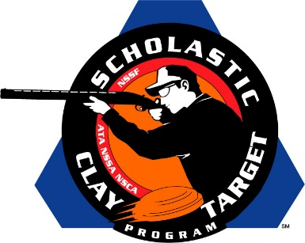

Illinois’ Brittany Youth Club Wins Intermediate/Advanced Division Trap National Title

SAN ANTONIO, Texas – With a 16 target lead, the Brittany Youth Club of Illinois won the Intermediate/Advanced Level Division title in the American Trap competition at the Scholastic Clay Target Program (SCTP) National Team Championships.

Held July 13-18 at the World Shooting and Recreational Complex in Sparta, Illinois, 2,466 athletes faced over 872,500 clay targets during six days of competition in the shooting disciplines for Trap, Skeet and Sporting Clays.

Breaking a combined 957 of 1,000 targets the Brittany Youth Club was led by Rowdy England (Carlinville) with 194 followed by Gage Thornton (Bethalto) with 191, Hunter Thornton (Bethalto) with 197, Nathan Cairns (Brighton) with 180 and Jacob Schnefke (New Douglas) with 195.

Second place went to the Volunteer State’s Cumberland County Clay Crushers with 941 targets.
Taylor Webb (Crossville) led the Tennessee squad with 196 targets followed by Darren Kittrell (Oakdale) with 191, Justin Reed (Crossville) with 186, Maci Gernt (Crossville) with 185 and Clint Kemmer (Crossville) with 183.

Missouri’s Gateway Claybusters, with 935 targets, finished third led by Joshua Dintleman (Fenton) with 191. Kramer Ennis (Fenton) broke 187 target, followed by Joseph Tubbs Jr (St. Charles) with 187, Hunter Spruill (St. Charles) with 186 and Jacob Humphrey (Sullivan) with 184.

Another Missouri squad took fourth. Jacob Penrod (Branson) with 195, Quinton Hinds (Branson) with 191, Tucker Trussell (Branson) with 185, Trenton King (Walnut Shade) with 182 and Gracie Dixon (Omaha, Ark.) with 180, combined for a total of 933 targets.

Rounding out the top five was the Waterford Wolverine Shooting Team of Wisconsin. Led by the division’s High Lady honoree, Jessica Strasser of Waterford, with 196, Wyatt Strasser (Waterford) with 189, Ross Bluhm (Mukwonago) with 184, Faith Moerke (Waterford) with 182 and Sam Holma (East Troy) with 177, posted a final team total of 928 targets.

The Scholastic Clay Target Program (SCTP) is a youth development program in which adult coaches and other volunteers use the shooting sports of Trap, Skeet and Sporting Clays, as well as the Olympic disciplines of Bunker Trap, Trap Doubles and International Skeet to teach and to demonstrate sportsmanship, responsibility, honesty, ethics, integrity, teamwork, and other positive life skills.

The Scholastic Shooting Sports Foundation, Inc. (SSSF), a 501(c)(3) nonprofit organization, is the National Governing Body for the Scholastic Clay Target Program. SCTP was started by the National Shooting Sports Foundation in 2001.

For more information about SCTP and SSSF, visit www.sssfonline.org. You can also follow SCTP on Facebook at www.facebook.com/ShootSCTP.

