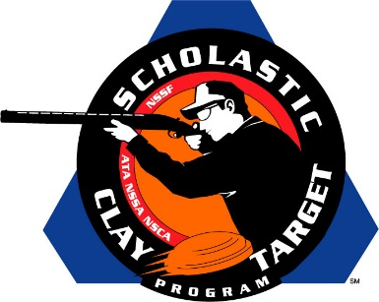

Branson Takes SCTP High School National Trap Title

SAN ANTONIO, Texas – The Branson Trap Team from Missouri, thanks to solid shooting and a near perfect 199 of 200 run by Kennedy Mattox (Branson), claimed the National High School title at the Scholastic Clay Target Program (SCTP) 2015 National Team Championships.

Held July 13-18 at the World Shooting and Recreational Complex in Sparta, Illinois, 2,466 athletes faced over 872,500 clay targets during six days of competition in the shooting disciplines for Trap, Skeet and Sporting Clays.

The Branson squad finished with a 974 target total with each shooter breaking over 190 targets. In addition to Mattox’s 199, Colten Calvert (Branson) broke 196 followed by Jacob Anderson (Branson) with 195, Kory Gray (Branson) with 192 and Gage Dixon (Omaha, Ark.) with 192.

Burlington (Wisc.) High School Demons Shooting Team squads took second and third in the competition. The second place squad of Weston Uhlenhake (Burlington) with 196, Zachary Hahn (Burlington) with 195, Hunter Conrad (Bristol) with 195, Jarod Hahn (Burlington) with 191 and Kaylee Lancour (Burlington) with 190 finished with a 967 total.

Just four targets back in third with 963 was the B.H.S. squad of Cody Kreuscher (Waterford) with 198, Cullen Kruser (Burlington) with 194, Brian Morris (Burlington) with 194, Boone Bubner (Burlington) with 191 and Tyler Regner (Burlington) with 186.

Rounding out the list of the top five trapshooting high school squads in the nation were the Maquoketa Cardinals of Iowa with 962, and the Central Falcons of Wisconsin with 961.

Maquoketa was led by Dylan Schepers (Delmar) with 197 followed by Lane Dundee (Maquoketa) with 195, Samuel Fowler (Maquoketa) with 191, Jake Schwenker (Maquoketa) with 190 and Kolton Manning (Maquoketa) with 189.

John Dietz (Kenosha), with his 195, led the Central Falcons squad of Bryan Griffey (Salem) with 193, Evan Wisniewski (Pleasant Prairie) with 193, Nathan Miller (Bristol) with 192 and Dalton Karow (Salem) with 188.

The Scholastic Clay Target Program (SCTP) is a youth development program in which adult coaches and other volunteers use the shooting sports of Trap, Skeet and Sporting Clays, as well as the Olympic disciplines of Bunker Trap, Trap Doubles and International Skeet to teach and to demonstrate sportsmanship, responsibility, honesty, ethics, integrity, teamwork, and other positive life skills.

The Scholastic Shooting Sports Foundation, Inc. (SSSF), a 501(c)(3) nonprofit organization, is the National Governing Body for the Scholastic Clay Target Program. SCTP was started by the National Shooting Sports Foundation in 2001.

For more information about SCTP and SSSF, visit www.sssfonline.org. You can also follow SCTP on Facebook at www.facebook.com/ShootSCTP.

