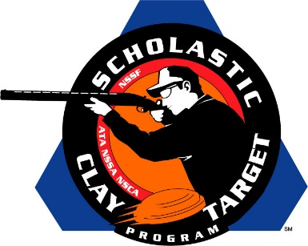

Lindenwood University Wins Collegiate Trap Title At SCTP Nationals

SAN ANTONIO, Texas – Breaking a total of 958 of their 1,000 targets, the squad from Lindenwood University claimed top collegiate honors in American Trap competition at the Scholastic Clay Target Program (SCTP) National Team Championships.

Led by Andrew Feig (Lenzburg) with 198, teammates Zach Nannini (St. Charles) with 197, Justin Phillips (St. Charles) with 192, Brad Beckmann (St. Charles) with 192 and Ryan Smithart (St. Charles) with 179 came together to give the Missouri school the first place finish.

Held July 13-18 at the World Shooting and Recreational Complex in Sparta, Illinois, 2,466 athletes faced over 872,500 clay targets during six days of competition in the shooting disciplines for Trap, Skeet and Sporting Clays.

Second place in the event went to the University of Iowa Shooting Sports Team where Michael Houston (Golden, Ill.) with 191, Richard Keimig (Davenport, Iowa) with 188, Chris Buckman (Iowa City) with 187, Brandon Throckmorton (Iowa City) with 187 and Brad Eveland (Iowa City) with 186 combined for a total of 939 targets.

Rounding out the top three was a Tennessee squad representing Covington 4-H with 918 targets. Amber Pruitt of McKenzie led with 189 followed by Jerrell Burns (Munford) with 188, Jordan Gray (Brighton) with 183, Dylan Owens (McKenzie) with 179 and Mikey Wright (Atoka) with 178.

The Scholastic Clay Target Program (SCTP) is a youth development program in which adult coaches and other volunteers use the shooting sports of Trap, Skeet and Sporting Clays, as well as the Olympic disciplines of Bunker Trap, Trap Doubles and International Skeet to teach and to demonstrate sportsmanship, responsibility, honesty, ethics, integrity, teamwork, and other positive life skills.

The Scholastic Shooting Sports Foundation, Inc. (SSSF), a 501(c)(3) nonprofit organization, is the National Governing Body for the Scholastic Clay Target Program. SCTP was started by the National Shooting Sports Foundation in 2001.

For more information about SCTP and SSSF, visit www.sssfonline.org. You can also follow SCTP on Facebook at www.facebook.com/ShootSCTP.

