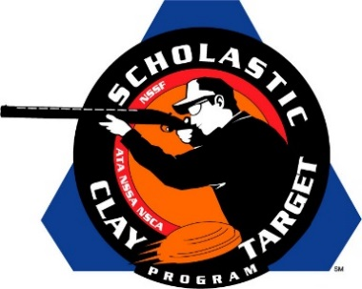

Henry Co. (Tenn.) No Fly Zone Varsity Squad Wins American Skeet National Title

SAN ANTONIO, Texas – Tennessee’s Henry Co. No Fly Zone Varsity Division squad broke 583 of 600 targets to win their division in American Skeet at the Scholastic Clay Target Program (SCTP) National Team Championships.

Held July 13-18 at the World Shooting and Recreational Complex in Sparta, Illinois, 2,466 athletes faced over 872,500 clay targets during six days of competition in the shooting disciplines for Trap, Skeet and Sporting Clays.

Hunter Fletcher of Paris and Caleb Orr Puryear led the No Fly Zone with 195 targets each. Teammate Briar Ray of Puryear finished with 193.

Second place went to the Haywood Young Guns, also of the Volunteer State, who claimed the title in Doubles Skeet. Finishing with a total of 580, Michael Hunter Campbell (Somerville) broke 197 followed by Zachary Tinsley (Bells) with 195 and Ford Ellington (Brownsville) with 188.

Three Georgia teams rounded out the top five in the division with Harris County Shotgun Team squads finishing third and fifth.

Rhett King (Fortson) with 193, Michaela Carder (Fortson) with 193 and Brandon Pitz (Catauala) with 192 combined for a third place total of 578, while Harrison Tew (Cataula) with 198, Ashton Terry (Woodland) with 190 and Thomas Solt (Pine Mountain) with 188 finished fifth with 576.

The Lake Oconee Shotgun Team claimed fourth with 577 targets and was led by Jasper Copelan (Eatonton) with 197, followed by Victor Shepherd (Oxford) with 192 and Taylor Hyatt (Greensboro) with 188.

The Scholastic Clay Target Program (SCTP) is a youth development program in which adult coaches and other volunteers use the shooting sports of Trap, Skeet and Sporting Clays, as well as the Olympic disciplines of Bunker Trap, Trap Doubles and International Skeet to teach and to demonstrate sportsmanship, responsibility, honesty, ethics, integrity, teamwork, and other positive life skills.

The Scholastic Shooting Sports Foundation, Inc. (SSSF), a 501(c)(3) nonprofit organization, is the National Governing Body for the Scholastic Clay Target Program. SCTP was started by the National Shooting Sports Foundation in 2001.

For more information about SCTP and SSSF, visit www.sssfonline.org. You can also follow SCTP on Facebook at www.facebook.com/ShootSCTP.

