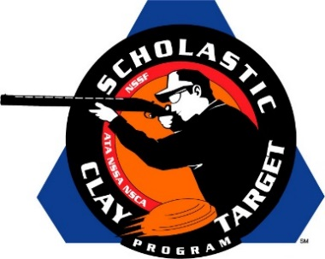

Top Guns For Men’s And Women’s American Skeet Named At SCTP Nationals

SAN ANTONIO, Texas – The top male and female athletes in American Skeet were recognized by the Scholastic Clay Target Program (SCTP) at the 2015 National Team Championships for their outstanding individual performances in each of its six competitive divisions.

Honored for their ability to break clay targets on the Skeet fields at the SCTP Nationals were women shooters Emily Shedd (Eloy, Ariz.) Central Arizona Target Shooters Rookie with 171; Ashley Blenker (Cooper City, Fla.) Young Guns At Quail Creek Intermediate/Entry Level with 169; Olivia Smith (Kalamazoo, Mich.) Mattawan Shooting Team Intermediate/Advanced with 186; Tori Mann (Hampstead, Md.) Mason-Dixon Clay Busters Senior/Jr. Varsity with 187; Skye McLain (Tennessee Ridge, Tenn.) Henry Co. No Fly Zone Senior/Varsity with 194; and Shelby Evans (Crawford, Ga.) Emmanuel College Clay Target Shooting Collegiate with 186.

Among the men competing this year the top performances came from Thomas Miles (Brooks, Ga.) of the Wolf Creek Shotgun Team Rookie with 189; Andrew Vanmiddlesworth (Climax, Mich.) Fudd Dusters Shotgun Sporting Team Intermediate/Entry Level with 190; Stuart Archer (Paris, Tenn.) Henry Co. No Fly Zone Intermediate/Advanced with 196; Joseph Reyes (Savannah, Ga.) Forest City Juniors Senior/Jr. Varsity with 197; Lake Heaton (Oskaloosa, Iowa) Oskaloosa Shooting Team Senior/Varsity with 198; and Brett Belrose (Ada, Mich.) KCCL Orange Crushers Collegiate with 199.

Held July 13-18 at the World Shooting and Recreational Complex in Sparta, Illinois, 2,466 athletes faced over 872,500 clay targets during six days of competition in the shooting disciplines for Trap, Skeet and Sporting Clays.

The Scholastic Clay Target Program (SCTP) is a youth development program in which adult coaches and other volunteers use the shooting sports of Trap, Skeet and Sporting Clays, as well as the Olympic disciplines of Bunker Trap, Trap Doubles and International Skeet to teach and to demonstrate sportsmanship, responsibility, honesty, ethics, integrity, teamwork, and other positive life skills.

The Scholastic Shooting Sports Foundation, Inc. (SSSF), a 501(c)(3) nonprofit organization, is the National Governing Body for the Scholastic Clay Target Program. SCTP was started by the National Shooting Sports Foundation in 2001.

For more information about SCTP and SSSF, visit www.sssfonline.org. You can also follow SCTP on Facebook at www.facebook.com/ShootSCTP.

