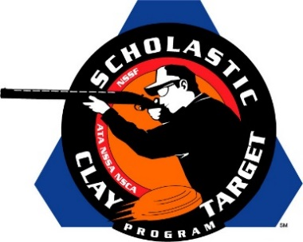

Kosko Dust Devils Of Indiana Claim Rookie Division American Skeet National Title

SAN ANTONIO, Texas – The Kosko Dust Devils of Indiana broke 506 of their 600 targets to claim the Rookie Division title in American Skeet at the Scholastic Clay Target Program (SCTP) National Team Championships.

The Dust Devils were led by Owen Knight (Macy) with 176, good enough for third among all Rookie Division shooters, followed by Nathan Creed (Plymouth) with 169 and Damian Cowan (Wabash) with 161.

Held July 13-18 at the World Shooting and Recreational Complex in Sparta, Illinois, 2,466 athletes faced over 872,500 clay targets during six days of competition in the shooting disciplines for Trap, Skeet and Sporting Clays.

Fresh off a fifth place finish in Sporting Clays, the Henry County No Fly Zone Rookie squad from Tennessee finished second with 463. Dalton Dodd (Paris) led the team breaking 171 of his 200 targets, followed by Will Overton (Paris) with 147 and Evan Bevill (Buchanan) 145.

Third place went to Tennessee’s Monroe County Shooting Team. Led by Archer Reese (Decatur) with 164, Lane Strickland (Niota) with 150 and Hunter Warren (Englewood) with 140 combined 454 targets. This same squad finished second in the Sporting Clays event.

Indiana’s squad, The Rangers Rookies, placed fourth with 445 targets. Jacob O’Dell (Mishawaka), who was fourth overall in the division, led the team with 173 targets. Nikolas Darmstatter (South Bend) added 140 targets followed by Alexander Darmstatter (South Bend) with 132.

Rounding out the top five was another Volunteer State shooting team, Southern Shooting Sports with 444. Seth Proctor (Clarksville) wit 161 and Ashton Ward (Clarksville) with 147 also shot on Southern Shooting Sports’ fifth place squad in the Sporting Clays competition. Teammate Isaiah Weakley (Ashland City) added his 136 to the Skeet squad’s total.

The Scholastic Clay Target Program (SCTP) is a youth development program in which adult coaches and other volunteers use the shooting sports of Trap, Skeet and Sporting Clays, as well as the Olympic disciplines of Bunker Trap, Trap Doubles and International Skeet to teach and to demonstrate sportsmanship, responsibility, honesty, ethics, integrity, teamwork, and other positive life skills.

The Scholastic Shooting Sports Foundation, Inc. (SSSF), a 501(c)(3) nonprofit organization, is the National Governing Body for the Scholastic Clay Target Program. SCTP was started by the National Shooting Sports Foundation in 2001.

For more information about SCTP and SSSF, visit www.sssfonline.org. You can also follow SCTP on Facebook at www.facebook.com/ShootSCTP.

