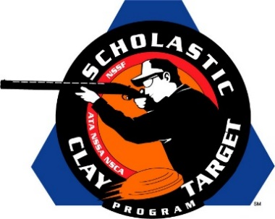

Haywood Young Guns (Tenn.) Capture Junior Varsity Division American Skeet National Title

SAN ANTONIO, Texas – Adding to their second place finish in Doubles Skeet, the Haywood Young Guns of Tennessee captured the Junior Varsity Division title in American Skeet at the Scholastic Clay Target Program (SCTP) National Team Championships.

Breaking 580 of their 600 targets, the Haywood Young Guns were led by Blake Robinson (Huron) with 194 followed by Jonathan Vandiver (Jackson) with 194 and Tritt Ellington (Brownsville) with 192.

Held July 13-18 at the World Shooting and Recreational Complex in Sparta, Illinois, 2,466 athletes faced over 872,500 clay targets during six days of competition in the shooting disciplines for Trap, Skeet and Sporting Clays.

Another Volunteer State squad finished second as the Henry County No Fly Zone broke 578 total targets with Aaron Conrad (Holladay) contributing 196, Scott Hicks (Camden) 193 and Gray Gardner (Paris) 189.

Third place went to the Flat River Conservation Club of Michigan. Brandon Kade (Coral) with 194 targets, Robert Cornell (Lakeview) with 193 and John Hallada (Howard City) with 189 combined for a total of 576.

Rounding out the top five were the Ft. Lee Dusters of Virginia, who took the title in Doubles Skeet, led by Hunter Belch (Suffolk) with 193, Logan R. Whitley (Suffolk) with 190 and Zachary Wells (Blackstone) with 187 for a fourth place total of 570. The Brookline Top Shots of Georgia, who took third in both Doubles Skeet and Sporting Clays, finished fifth with Kevin Bandt (Fort Valley) breaking 193, Alexis Eidson (Byron) with 187 and Chase Crutchfield (Round Oak) with 184 combining for a total of 564.

The Scholastic Clay Target Program (SCTP) is a youth development program in which adult coaches and other volunteers use the shooting sports of Trap, Skeet and Sporting Clays, as well as the Olympic disciplines of Bunker Trap, Trap Doubles and International Skeet to teach and to demonstrate sportsmanship, responsibility, honesty, ethics, integrity, teamwork, and other positive life skills.

The Scholastic Shooting Sports Foundation, Inc. (SSSF), a 501(c)(3) nonprofit organization, is the National Governing Body for the Scholastic Clay Target Program. SCTP was started by the National Shooting Sports Foundation in 2001.

For more information about SCTP and SSSF, visit www.sssfonline.org. You can also follow SCTP on Facebook at www.facebook.com/ShootSCTP.

