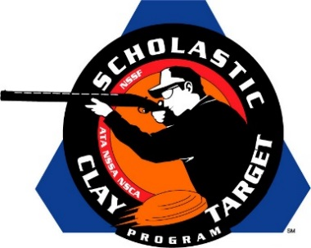

Clarksville High (Tenn.) Takes Intermediate/Entry Level Division American Skeet National Title

SAN ANTONIO, Texas – A trio of shooters from Clarksville, Tenn., won the American Skeet title in the Intermediate/Entry Level Division at the Scholastic Clay Target Program (SCTP) National Team Championships.

Breaking 189 of his 200 targets, Elijah McGaha led the Clarksville High Shooting Sports Eagle squad with Hunter Crosby (Clarksville) breaking 174 and Cameron Durrett (Clarksville) adding 173 to combine for a team total of 536.

Held July 13-18 at the World Shooting and Recreational Complex in Sparta, Illinois, 2,466 athletes faced over 872,500 clay targets during six days of competition in the shooting disciplines for Trap, Skeet and Sporting Clays.

Second place went to Florida’s Young Guns At Quail Creek with 533. Joseph Fanizzi (Okeechobee) and Landon Smoak (Lake Placid), who were both on the Young Guns squad that took the Sporting Clays title, broke 188 and 176 targets respectively. Teammate Ashley Blenker (Cooper City) finished with 169 targets.

Arizona’s Ben Avery Clay Crushers, the fifth place squad in Sporting Clays, finished third with 529. Victor Cordova (Cave Creek) led the team with 189 targets while Christopher Welsh (Peoria) broke 180 and Griffin Toliver (Phoenix) added another 160.

Rounding out the top five in the division were teams from Georgia and Tennessee. The Forest City Juniors of Georgia took fourth with 527 and were led by Walker McDonald (Savannah) with 180, followed by Colin Davis (Statesboro) with 174 and Jake Summerford (Savannah) 173. Both McDonald and Davis previously helped Forest City take second in the Sporting Clays Nationals.

Three shooters from McKenzie, Tenn., gave McKenzie Shooting Sports a fifth place finish. Richard Clay Wilson, who competed on McKenzie’s fourth place Sporting Clays squad, finished with 179, while Nathan Nanny broke 169 and Logan Green 163 to combine for a total of 511.

The Scholastic Clay Target Program (SCTP) is a youth development program in which adult coaches and other volunteers use the shooting sports of Trap, Skeet and Sporting Clays, as well as the Olympic disciplines of Bunker Trap, Trap Doubles and International Skeet to teach and to demonstrate sportsmanship, responsibility, honesty, ethics, integrity, teamwork, and other positive life skills.

The Scholastic Shooting Sports Foundation, Inc. (SSSF), a 501(c)(3) nonprofit organization, is the National Governing Body for the Scholastic Clay Target Program. SCTP was started by the National Shooting Sports Foundation in 2001.

For more information about SCTP and SSSF, visit www.sssfonline.org. You can also follow SCTP on Facebook at www.facebook.com/ShootSCTP.

