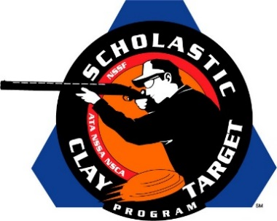

No Fly Zone (Tenn.) Claims Intermediate/Advanced Level Division American Skeet National Title

SAN ANTONIO, Texas – The Henry County No Fly Zone of Tennessee claimed the Intermediate/Advanced Level Division in American Skeet at the Scholastic Clay Target Program (SCTP) National Team Championships.

Held July 13-18 at the World Shooting and Recreational Complex in Sparta, Illinois, 2,466 athletes faced over 872,500 clay targets during six days of competition in the shooting disciplines for Trap, Skeet and Sporting Clays.

Combining for a first place total of 558 out of a possible 600 targets, Stuart Archer (Paris) led the No Fly Zone with 196, followed by Drew James (Paris) with 188 and Bryce Townsend (Paris) with 174.

Second place went to another group of Volunteer State shooters, the Southern Shooting Sports squad. Austin Brown (Cumberland City) with 190, Ely Weakley (Ashland City) with 183 and Fred Peters (Clarksville) with 183 combined for Southern Shooting Sports’ total of 556.

Georgia’s Harris County Shotgun Team, with 547, placed third with Avery Lawski (Waverly Hall) leading with 191 targets followed by Gabriel Tharpe (Hamilton) with 185 and Mark Berndt (Cataula) with 171.

The Mattawan Shooting Team from Michigan finished fourth breaking 545 of 600 targets. Olivia Smith (Kalamazoo) led the squad with 186 targets followed by Justin Hillsburg (Mattawan) with 186 and Kyle Fleck (Schoolcraft) with 173.

Rounding out the top five was another Michigan team, the KCCL Orange Crushers. Combining for a total of 544, Connor Kooistra (Ada) broke 186 targets, while Jake Lotterman (Ada) and Jadon Butler (Sherdian) shot 180 and 178 respectively.

The Scholastic Clay Target Program (SCTP) is a youth development program in which adult coaches and other volunteers use the shooting sports of Trap, Skeet and Sporting Clays, as well as the Olympic disciplines of Bunker Trap, Trap Doubles and International Skeet to teach and to demonstrate sportsmanship, responsibility, honesty, ethics, integrity, teamwork, and other positive life skills.

The Scholastic Shooting Sports Foundation, Inc. (SSSF), a 501(c)(3) nonprofit organization, is the National Governing Body for the Scholastic Clay Target Program. SCTP was started by the National Shooting Sports Foundation in 2001.

For more information about SCTP and SSSF, visit www.sssfonline.org. You can also follow SCTP on Facebook at www.facebook.com/ShootSCTP.

