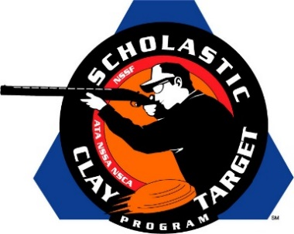

Harris County (Ga.) Shotgun Team Takes SCTP High School National Title In American Skeet

SAN ANTONIO, Texas – Harrison Tew of Cataula dropped just two of his 200 targets to lead his Harris County (Ga.) Shotgun Team squamates, Michaela Carder (Fortson) with 193 and Rhett King (Fortson) with 193, to take the High School title with 584 targets in American Skeet at the Scholastic Clay Target Program (SCTP) 2015 National Team Championships.

Held July 13-18 at the World Shooting and Recreational Complex in Sparta, Illinois, 2,466 athletes faced over 872,500 clay targets during six days of competition in the shooting disciplines for Trap, Skeet and Sporting Clays.

Second place among high school teams went to the Central Falcons of Wisconsin with 575. Benjamin Schroeder (Cherry Valley) led with 198, followed by John Dietz (Kenosha) with 195 and Nicholas Thomey (Kenosha) with 182.

The Pinckneyville Community High School squad from Illinois finished third. Andy Opp and Tyler Thomas, who were part of the PCHS title winning Sporting Clays squad and both hail from Pinckneyville, broke 194 and 190 targets respectively. Their teammate Trey Bourque (Du Bois) finished with 190 to give the team a total of 574.

Rounding out the top five were teams from Texas and Iowa, both with 573 total targets.

The Lone Star State’s Allen Eagles Competitive Shooting Team finished with Brandon Stone (Plano) breaking 194, O. Cecil Linke, III (Allen) 191 and Lake Bishop (Allen) 188. Linke was also part of the Allen Eagles team that finished second in Sporting Clays.

The Oskaloosa Shooting Team was led by Lake Heaton with 198, followed by Jason Herr, who was part of Oskaloosa’s fourth place Sporting Clays team, with 188 and Ethan Kelderman with 187. All three shooters hail from Oskaloosa, Iowa.

The Scholastic Clay Target Program (SCTP) is a youth development program in which adult coaches and other volunteers use the shooting sports of Trap, Skeet and Sporting Clays, as well as the Olympic disciplines of Bunker Trap, Trap Doubles and International Skeet to teach and to demonstrate sportsmanship, responsibility, honesty, ethics, integrity, teamwork, and other positive life skills.

The Scholastic Shooting Sports Foundation, Inc. (SSSF), a 501(c)(3) nonprofit organization, is the National Governing Body for the Scholastic Clay Target Program. SCTP was started by the National Shooting Sports Foundation in 2001.

For more information about SCTP and SSSF, visit www.sssfonline.org. You can also follow SCTP on Facebook at www.facebook.com/ShootSCTP.

