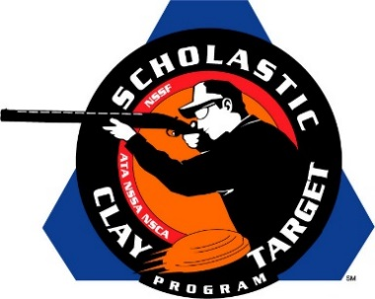

Belrose Leads KCCL Orange Crushers To Collegiate Division American Skeet Title

SAN ANTONIO, Texas – Breaking 586 of their 600 targets, including a near perfect 199 of 200 High Overall performance by Brett Belrose (Ada), the KCCL Orange Crushers of Michigan took home the Collegiate Division Skeet title during competition at the Scholastic Clay Target Program (SCTP) National Team Championships.

Belrose’s 199 topped all shooters competing in American Skeet at the 2015 National Team Championships. Helping him secure the title win for the KCCL Orange Crushers were teammates Hunter Brander (Ada) with 196 and Tyler Moore (Grand Rapids) with 191.

Held July 13-18 at the World Shooting and Recreational Complex in Sparta, Illinois, 2,466 athletes faced over 872,500 clay targets during six days of competition in the shooting disciplines for Trap, Skeet and Sporting Clays.

The squad from Lindenwood University in Missouri took second with a total of 574 targets.
Justin Phillips (St. Charles, Mo.) led Lindenwod with 195, followed by Zach Nannini (St. Charles, Mo.) with 190 and Andrew Feig (Lenzburg, Mo.) with 189.

Third place, with 570 targets, went to the Decatur Gun Club Target Terminators of Illinois who were led by Joel Ashburn (Taylorville) with 195. Braden Highcock (Oakley) added 190 targets while Ryan Galloway (Decatur) broke another 185 towards the team’s total.

The Scholastic Clay Target Program (SCTP) is a youth development program in which adult coaches and other volunteers use the shooting sports of Trap, Skeet and Sporting Clays, as well as the Olympic disciplines of Bunker Trap, Trap Doubles and International Skeet to teach and to demonstrate sportsmanship, responsibility, honesty, ethics, integrity, teamwork, and other positive life skills.

The Scholastic Shooting Sports Foundation, Inc. (SSSF), a 501(c)(3) nonprofit organization, is the National Governing Body for the Scholastic Clay Target Program. SCTP was started by the National Shooting Sports Foundation in 2001.

For more information about SCTP and SSSF, visit www.sssfonline.org. You can also follow SCTP on Facebook at www.facebook.com/ShootSCTP.

