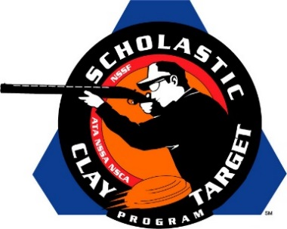

Florida’s Varsity Young Guns Top All Sporting Clays Teams At SCTP Nationals

SAN ANTONIO, Texas – The varsity division squad for Florida’s Young Guns At Quail Creek posted the top overall score in the Scholastic Clay Target Program (SCTP) 2015 National Team Championships breaking 552 of their 600 targets.

Held July 13-18 at the World Shooting and Recreational Complex in Sparta, Illinois, 2,466 athletes faced over 872,500 clay targets during six days of competition in the shooting disciplines for Trap, Skeet and Sporting Clays.

Sam Hayden-Kaplan of Palm Beach Gardens led the Young Guns and placed fourth overall with 189 targets. Zach Metz of Vero Beach and Nicholas Blenker of Cooper City each broke 187 and 176 respectively.

The top High School team in the competition, the Pinckneyville Community High School (PCHS) Varsity Red squad of Illinois, took second with 549. Andy Opp of Pinckneyville was High Overall among all Sporting Clays athletes with a total of 195 targets. Tyler Thomas added 184 targets to the total while Ellie Winder added 170. Both shooters are also from Pinckneyville.

The Etowah Valley Mambas Varsity A squad from Georgia placed third. Dawson Peer of Woodstock (187), Jack Elwell of Canton (179) and Mitchell McCraney of Buford (176) combined for a total of 542.

The Varsity 2 squad for the Young Guns finished fourth with 533. Jack Martinelli of Vero Beach led with 182 while Clayton Cutshall of Alva broke 180 and Layton Chambers of Ft. Pierce 171.

Rounding out the top five was the Allen Eagles Competitive Shooting Team 1 from the Lone Star State. Texas shooters Nolan Baker of Allen (178), Jacob Freudenthal of Lucas (173) and Hunter Alford of Allen (173) combined for a total of 524.

The Scholastic Clay Target Program (SCTP) is a youth development program in which adult coaches and other volunteers use the shooting sports of Trap, Skeet and Sporting Clays, as well as the Olympic disciplines of Bunker Trap, Trap Doubles and International Skeet to teach and to demonstrate sportsmanship, responsibility, honesty, ethics, integrity, teamwork, and other positive life skills.

The Scholastic Shooting Sports Foundation, Inc. (SSSF), a 501(c)(3) nonprofit organization, is the National Governing Body for the Scholastic Clay Target Program. SCTP was started by the National Shooting Sports Foundation in 2001.

For more information about SCTP and SSSF, visit www.sssfonline.org. You can also follow SCTP on Facebook at www.facebook.com/ShootSCTP.

