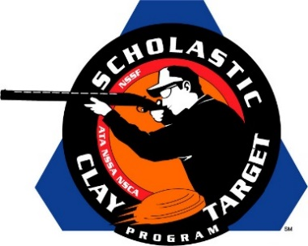

Men’s And Women’s Sporting Clays Top Guns Named At SCTP Nationals

SAN ANTONIO, Texas – Though designed as a team sport, the Scholastic Clay Target Program (SCTP) each year recognizes the outstanding individual performances in each of its six competitive divisions at the National Team Championships.

Honored for their ability to break clay targets on the challenging sporting clays course at the SCTP Nationals were women shooters Emily Shedd (Eloy, Ariz.) with the Central Arizona Target Shooters who broke 140 in the Rookie Division; Madison Sharpe (North, S.C.) of the Richland Creek Top Guns in Intermediate/Entry Level Division with 152; Camryn McCraney (Buford, Ga.) shooting for the Etowah Valley Mambas in the Intermediate/Advanced Division with 168; Quincy Standage (Springfield, Mo.) of the Branson Trap Team in the Junior Varsity Division with 176; Jordan Osborne (Lynnville, Tenn.) of Richland Trap & Sporting Clays in the Varsity Division with 181; and Shelby Evans (Crawford, Ga.) of the Emmanuel College Clay Target Shooting Team in the Collegiate Division with 187.

Among the men competing this year the top performances came from Trevor Hinton (Riverview, Fla.) of the FishHawk Dynasty leading the Rookie Division with 164; Cole Prince (Sweetwater, Tenn.) of the Monroe County Shooting Team in the Intermediate/Entry Level Division with 175; Gage Thornton (Bethalto, Ill.) of the Brittany Youth Club in the Intermediate/Advanced Division with 186; Dalton Kirchhoefer (Parker, Colo.) with the Rocky Mountain Clay Busters in the Junior Varsity Division with 190; Andy Opp (Pinckneyville, Ill.) of the Pinckneyville Community High School in the Varsity Division with 195; and Mike Esposito (Jacksonville, Fla. ) with the Jacksonville University Sporting, Skeet & Trap Team in the Collegiate Division with 191.

Held July 13-18 at the World Shooting and Recreational Complex in Sparta, Illinois, 2,466 athletes faced over 872,500 clay targets during six days of competition in the shooting disciplines for Trap, Skeet and Sporting Clays.

The Scholastic Clay Target Program (SCTP) is a youth development program in which adult coaches and other volunteers use the shooting sports of Trap, Skeet and Sporting Clays, as well as the Olympic disciplines of Bunker Trap, Trap Doubles and International Skeet to teach and to demonstrate sportsmanship, responsibility, honesty, ethics, integrity, teamwork, and other positive life skills.

The Scholastic Shooting Sports Foundation, Inc. (SSSF), a 501(c)(3) nonprofit organization, is the National Governing Body for the Scholastic Clay Target Program. SCTP was started by the National Shooting Sports Foundation in 2001.

For more information about SCTP and SSSF, visit www.sssfonline.org. You can also follow SCTP on Facebook at www.facebook.com/ShootSCTP.

