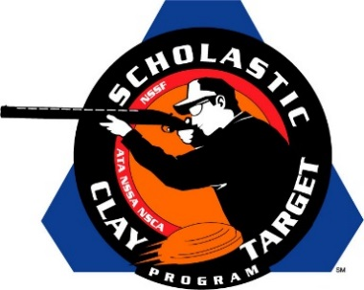

FishHawk Dynasty Takes Rookies Division Sporting Clays National Title

SAN ANTONIO, Texas – Florida’s FishHawk Dynasty shooting team took the Rookies Division title in Sporting Clays breaking 414 of the possible 600 targets at the Scholastic Clay Target Program (SCTP) National Team Championships. Held July 13-18 at the World Shooting and Recreational Complex in Sparta, Illinois, 2,466 athletes faced over 872,500 clay targets during six days of competition in the shooting disciplines for Trap, Skeet and Sporting Clays.

Led by Trevor Hinton of Riverview who broke 164 targets, teammates Nash Sollmann of Plant City and Abigale Wigh of Dover added 131 and 119 targets respectively. Hinton’s 164 also earned him Mens Rookie High Overall individual honors while Wigh’s 119 placed her third overall among the women in the division.

Second place in the division went to the Monroe County Rookies of Tennessee with a score of 399. Archer Reese of Decatur (160), Lane Strickland of Niota (126) and Hunter Warren of Englewood (113) combined for a total of 399. Reese finished third overall among all Rookie Division competitors.

Georgia’s Lake Oconee Shotgun Team’s Rookie Squad of Tyler Urrutia of Greensboro (139) and Jake Grimes (124) and Dylan Sinclair (112) of Eatonton claimed third with 375 targets.

Tennessee shooters Dalton Dodd and Will Overton of Paris along with Evan Bevill of Buchanan combined to take fourth place for the Henry County No Fly Zone team with 364 by breaking 132, 125 and 107 targets respectively.

Rounding out the top five was another Volunteers State team, the Southern Shooting Sports. Seth Proctor (137) and Ashton Ward (108) of Clarksville and Anderson Brown (113) of Cumberland City broke a total of 358 of their 600 targets.

The Scholastic Clay Target Program (SCTP) is a youth development program in which adult coaches and other volunteers use the shooting sports of Trap, Skeet and Sporting Clays, as well as the Olympic disciplines of Bunker Trap, Trap Doubles and International Skeet to teach and to demonstrate sportsmanship, responsibility, honesty, ethics, integrity, teamwork, and other positive life skills.

The Scholastic Shooting Sports Foundation, Inc. (SSSF), a 501(c)(3) nonprofit organization, is the National Governing Body for the Scholastic Clay Target Program. SCTP was started by the National Shooting Sports Foundation in 2001.

For more information about SCTP and SSSF, visit www.sssfonline.org. You can also follow SCTP on Facebook at www.facebook.com/ShootSCTP.

