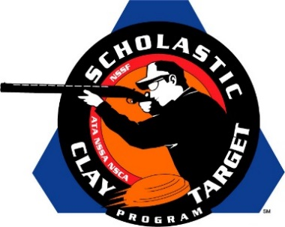

Florida’s Young Guns Claim Junior Varsity Division Sporting Clays National Title

SAN ANTONIO, Texas – Picking up another national win, Florida’s Young Guns At Quail Creek JV squad claimed the Junior Varsity Division title in Sporting Clays at the Scholastic Clay Target Program (SCTP) National Team Championships breaking 539 of their 600 targets.

Held July 13-18 at the World Shooting and Recreational Complex in Sparta, Illinois, 2,466 athletes faced over 872,500 clay targets during six days of competition in the shooting disciplines for Trap, Skeet and Sporting Clays.

The Young Guns team finished strong with Ace Zorro of Lake Placid taking second overall in the division with 189. Jay Bible of Sebring broke 177 targets while Maggie Metz of Vero Beach crushed 173 to finish second High Lady.

Colorado’s Rocky Mountain Clay Busters took second with 527. Dalton Kirchhoefer of Parker led the team with 190 targets which placed him High Overall in the division. Jacob Dame of Franktown finished with 169 while teammate Cameron Dines of Parker broke 168.

Third place, with 517, went to the Brookline Top Shots of Georgia. Kevin Bandt of Fort Valley placed third overall in the division with 187. Alexis Eidson of Byron was the third High Lady with 167 while Chase Crutchfield of Round Oak added 163 to the team total.

A trio of McKenzie, Tennessee, shooters broke 497 targets to give the McKenzie Shooting Sports Caba Cobras a fourth place finish. Anders Rider, Jacob Pinson and Dalton Dyer shot 182, 166 and 149 respectively.

The Varsity Orange squad from nearby Pinckneyville Community High School in Illinois posted 494 targets for fifth place. Max Fox of Pinckneyville led the team with 183 with Dalton Pyatt, also of Pinckneyville, adding 166 and Mychal Pfeaster of Tamaroa another 145.

The Scholastic Clay Target Program (SCTP) is a youth development program in which adult coaches and other volunteers use the shooting sports of Trap, Skeet and Sporting Clays, as well as the Olympic disciplines of Bunker Trap, Trap Doubles and International Skeet to teach and to demonstrate sportsmanship, responsibility, honesty, ethics, integrity, teamwork, and other positive life skills.

The Scholastic Shooting Sports Foundation, Inc. (SSSF), a 501(c)(3) nonprofit organization, is the National Governing Body for the Scholastic Clay Target Program. SCTP was started by the National Shooting Sports Foundation in 2001.

For more information about SCTP and SSSF, visit www.sssfonline.org. You can also follow SCTP on Facebook at www.facebook.com/ShootSCTP.

