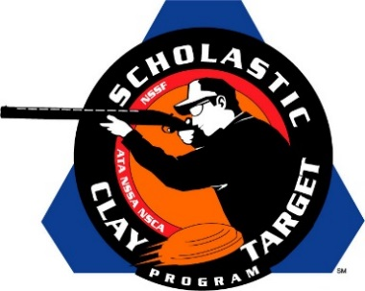

Florida’s Young Guns Take Intermediate/Entry Level Division Sporting Clays National Title

SAN ANTONIO, Texas – Breaking 472 of the possible 600 targets the Young Guns At Quail Creek shooting team from Florida took the Intermediate/Entry Level Division title in Sporting Clays at the Scholastic Clay Target Program (SCTP) National Team Championships. Held July 13-18 at the World Shooting and Recreational Complex in Sparta, Illinois, 2,466 athletes faced over 872,500 clay targets during six days of competition in the shooting disciplines for Trap, Skeet and Sporting Clays.

Landon Smoak of Lake Placid led the Young Guns by breaking 164 targets followed by teammates Joseph Fanizzi of Okeechobee with 156 and Kagen Long of St. Cloud with 152.

Second and third place in the division went to teams out of Georgia. Walker McDonald (159) and Kline Barfield (156) of Savannah and Colin Davis (152) of Statesboro took second for the Forest City Juniors with 467 total targets. The Etowah Valley Mambas captured third with Cupper Johnson (168) of Jasper, Camden Gillespie (147) of Gainesville and Tucker Thomas (147) of Cumming combining for 462. Johnson placed fourth overall within the division.

The McKenzie Shooting Sports’ Caba Cannons from the Volunteer State of Tennessee finished fourth with 451. Richard Clay, Logan Green and Nathan Nanny, all from McKenzie, broke 155, 153 and 143 targets respectively.

Arizona’s Ben Avery Clay Crushers, led by Christopher Welsh of Peoria who finished second overall in the division with 170, placed fifth with 440 total targets with Griffin Toliver of Phoenix breaking 141 targets and Victor Cordova of Cave Creek with 129.

The Scholastic Clay Target Program (SCTP) is a youth development program in which adult coaches and other volunteers use the shooting sports of Trap, Skeet and Sporting Clays, as well as the Olympic disciplines of Bunker Trap, Trap Doubles and International Skeet to teach and to demonstrate sportsmanship, responsibility, honesty, ethics, integrity, teamwork, and other positive life skills.

The Scholastic Shooting Sports Foundation, Inc. (SSSF), a 501(c)(3) nonprofit organization, is the National Governing Body for the Scholastic Clay Target Program. SCTP was started by the National Shooting Sports Foundation in 2001.

For more information about SCTP and SSSF, visit www.sssfonline.org. You can also follow SCTP on Facebook at www.facebook.com/ShootSCTP.

