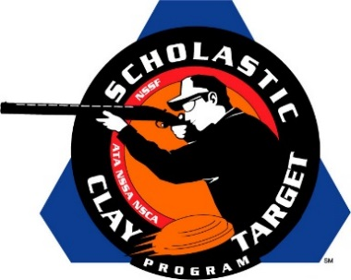

Brittany Youth Club of Illinois Wins Intermediate/Advanced Division Sporting Clays National Title

SAN ANTONIO, Texas – Competing in their home state of Illinois, the Brittany Youth Club shooting team captured the Intermediate/Advanced Division title in Sporting Clays at the Scholastic Clay Target Program (SCTP) National Team Championships by breaking 533 of their 600 targets.

Held July 13-18 at the World Shooting and Recreational Complex in Sparta, Illinois, 2,466 athletes faced over 872,500 clay targets during six days of competition in the shooting disciplines for Trap, Skeet and Sporting Clays.

Gage Thornton, breaking 186 to take High Overall within the division, led teammates Hunter Thornton of Bethalto (178) and Rowdy England of Carlinville (169) to the coveted national title.

Second place went to Georgia’s Lake Oconee Shotgun Team. Teammates Riley Downs of Mitchell (177) and Aaron Copelan (176) and Jaden Grimes (165) of Eatonton combined for a total of 514.

Florida’s Young Guns At Quail Creek finished third with Joseph Pinchin of Pembrook Pines (178), Bryan Quigley of Fort Pierce (165) and Gavin Driggers of Okeechobee (160) breaking 503 total targets.

Justin Reed and Clint Kemmer of Crossville, joined by Corbin Moore of Rockwood, shot 179, 171 and 150 respectively to give the Cumberland County Clay Crushers’s Red squad of Tennessee a 500 target fourth place finish. Reed took fifth overall within the division.

Rounding out the top five was another Georgia team, the Etowah Valley Mambas. Camryn McCraney of Buford, the division’s High Lady with 168, Wyatt Leger, also of Buford, with 165 and Max Earley of Alpharetta with 155 combined for a 488 total.

The Scholastic Clay Target Program (SCTP) is a youth development program in which adult coaches and other volunteers use the shooting sports of Trap, Skeet and Sporting Clays, as well as the Olympic disciplines of Bunker Trap, Trap Doubles and International Skeet to teach and to demonstrate sportsmanship, responsibility, honesty, ethics, integrity, teamwork, and other positive life skills.

The Scholastic Shooting Sports Foundation, Inc. (SSSF), a 501(c)(3) nonprofit organization, is the National Governing Body for the Scholastic Clay Target Program. SCTP was started by the National Shooting Sports Foundation in 2001.

For more information about SCTP and SSSF, visit www.sssfonline.org. You can also follow SCTP on Facebook at www.facebook.com/ShootSCTP.

