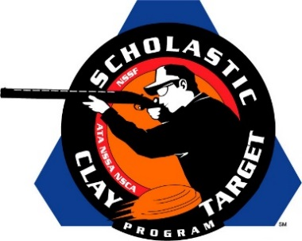

Pinckneyville Takes SCTP High School National Sporting Clays Title

SAN ANTONIO, Texas – Andy Opp dropped a mere five of his 200 targets while leading his Pinckneyville (Illinois) Community High School (PCHS) teammates Tyler Thomas (184) and Max Fox (183) to a final score of 562 and the National High School title at the Scholastic Clay Target Program (SCTP) 2015 National Team Championships.

Held July 13-18 at the World Shooting and Recreational Complex in Sparta, Illinois, 2,466 athletes faced over 872,500 clay targets during six days of competition in the shooting disciplines for Trap, Skeet and Sporting Clays.

The Allen Eagles Competitive Shooting Team of Texas took second with 544 with O. Cecil Linke, III breaking 185, Phillip Segner 181 and Nolan Baker 171. All three shooters hail from Allen.

The Volunteer State’s Soddy Daisy squad placed third with 527. Cody Hedgecoth and Zach Read of Soddy Daisy each broke 180 and 176 targets respectively while Eli Christman of Hixson finished with 171 targets.

Iowa’s Oskaloosa Shooting Team finished fourth. Lauren Herr broke 173 targets followed by Cole Waite with 169 and Jason Herr with 168. All three reside in Oskaloosa.

Rounding out the top five High School teams at this year’s Nationals was another Iowa team, the Pella Shooters Club. Combining for a total of 508 targets were Remington Schroder (172) and Kolbie Van Dusseldorp (169) of Leighton and Trent Schippers (167) of Monroe.

The Scholastic Clay Target Program (SCTP) is a youth development program in which adult coaches and other volunteers use the shooting sports of Trap, Skeet and Sporting Clays, as well as the Olympic disciplines of Bunker Trap, Trap Doubles and International Skeet to teach and to demonstrate sportsmanship, responsibility, honesty, ethics, integrity, teamwork, and other positive life skills.

The Scholastic Shooting Sports Foundation, Inc. (SSSF), a 501(c)(3) nonprofit organization, is the National Governing Body for the Scholastic Clay Target Program. SCTP was started by the National Shooting Sports Foundation in 2001.

For more information about SCTP and SSSF, visit www.sssfonline.org. You can also follow SCTP on Facebook at www.facebook.com/ShootSCTP.

