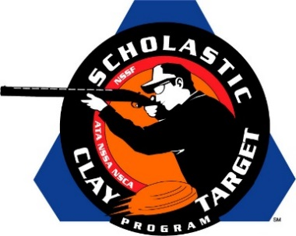

Missouri’s Wildcat Trap Varsity Tops All Handicap Trap Teams At SCTP Nationals

SAN ANTONIO, Texas – The Wildcat Trap Varsity Division squad out of Missouri posted the top score of all teams competing in Handicap Trap competition with 894 of 1,000 targets broken during the Scholastic Clay Target Program (SCTP) 2015 National Team Championships.

Held July 13-18 at the World Shooting and Recreational Complex in Sparta, Illinois, 2,466 athletes faced over 872,500 clay targets during six days of competition in the shooting disciplines for Trap, Skeet and Sporting Clays.

The Wildcats were led by Joshua Galloway (Fordland) with 189 followed by Ethan Boyer (Rogersville) with 178, Caleb Miller (Rogersville) and Chase Jacopian (Rogersville) with 177 each and Cole Perry (Rogersville) with 173.

Second place in the division went to the Maquoketa Cardinals from Iowa. With a division high of 190 targets, Samuel Fowler (Maquoketa) led his varsity squad. Kolton Manning (Maquoketa) and Clinton Manning (Maquoketa) each added 178 while Kaden Waack (Maquoketa) broke 177 and Dylan Schepers (Delmar) another 163.

Wisconsin’s Rice Lake Warrbirds placed third. Andrew Doane (Rice Lake) with 181, Sam King (Birchwood) with 171, Lane Reinikainen (Rice Lake) with 160, Justin Meyers (Rice Lake) with 156 and Sam Hovde (Birchwood) with 152 combined for a podium finish total of 820.

The Scholastic Clay Target Program (SCTP) is a youth development program in which adult coaches and other volunteers use the shooting sports of Trap, Skeet and Sporting Clays, as well as the Olympic disciplines of Bunker Trap, Trap Doubles and International Skeet to teach and to demonstrate sportsmanship, responsibility, honesty, ethics, integrity, teamwork, and other positive life skills.

The Scholastic Shooting Sports Foundation, Inc. (SSSF), a 501(c)(3) nonprofit organization, is the National Governing Body for the Scholastic Clay Target Program. SCTP was started by the National Shooting Sports Foundation in 2001.

For more information about SCTP and SSSF, visit www.sssfonline.org. You can also follow SCTP on Facebook at www.facebook.com/ShootSCTP.

