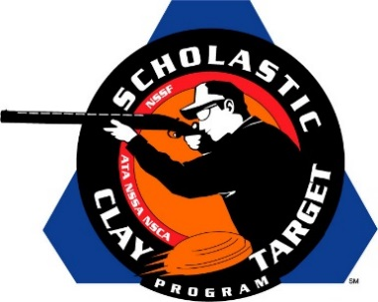

Top Guns For Men’s And Women’s Handicap Trap Named At SCTP Nationals

SAN ANTONIO, Texas – The top male and female athletes in Handicap Trap were recognized by the Scholastic Clay Target Program (SCTP) at the 2015 National Team Championships for their outstanding individual performances in each of its six competitive divisions.

Honored for their ability to break clay targets on the Handicap Trap fields at the SCTP Nationals were women shooters Sheaffer Stanfill (Clarksville, Tenn.) of the Montgomery County Youth Shooting Sports who broke 173 in the Rookie Division; Chase Perry (Rogersville, Mo.) of the Wildcat Trap team in the Intermediate/Entry Level Division with 178; Alex York (Lanark, Ill.) of the YSSA Orange Crushers in the Intermediate/Advanced Division with 189; Joseph Leonard (Rogersville, Mo.) of the Wildcat Trap team in the Junior Varsity Division with 184; Samuel Fowler (Maquoketa, Iowa) of the Maquoketa Cardinals in the Varsity Division with 190; Luke Schmedeke (Morrisonville, Ill.) of the Edgewood Scholastic Shooting Team in the Senior/Varsity Division with 190; and William Faeth (Ft. Madison, Iowa) of the Ft. Madison Clay Crushers in the Collegiate Division with 180.

Among the men competing this year the top performances came from Carey Garrison (Crossville, Tenn.) of the Cumberland County Clay Crushers in the Rookie Division with 157; Morgan Clark (Mayville, Wisc.) of the Flyway Clay Slayers in the Intermediate/Entry Level Division with 149; Rae Woods (Reeds Spring, Mo.) of the Branson Trap Team in the Intermediate/Entry Level Division with 149; Kirstan Pfeiffer (Barnhart, Mo.) of the Arnold Junior Shooters in the Intermediate/Advanced Division with 182; Corrine Schneider (Burlington, Wisc.) of the B.H.S. Demons Shooting Team in the Junior Varsity Division with 159; Joy Bral (Storm Lake, Iowa) of the Storm Lake High Trapshooters in the Varsity Division with 184; and Shelby Simmons (Brighton, Tenn.) of the University of Tenn. – Martin team in the Collegiate Division with 164.

Held July 13-18 at the World Shooting and Recreational Complex in Sparta, Illinois, 2,466 athletes faced over 872,500 clay targets during six days of competition in the shooting disciplines for Trap, Skeet and Sporting Clays.

The Scholastic Clay Target Program (SCTP) is a youth development program in which adult coaches and other volunteers use the shooting sports of Trap, Skeet and Sporting Clays, as well as the Olympic disciplines of Bunker Trap, Trap Doubles and International Skeet to teach and to demonstrate sportsmanship, responsibility, honesty, ethics, integrity, teamwork, and other positive life skills.

The Scholastic Shooting Sports Foundation, Inc. (SSSF), a 501(c)(3) nonprofit organization, is the National Governing Body for the Scholastic Clay Target Program. SCTP was started by the National Shooting Sports Foundation in 2001.

For more information about SCTP and SSSF, visit www.sssfonline.org. You can also follow SCTP on Facebook at www.facebook.com/ShootSCTP.

