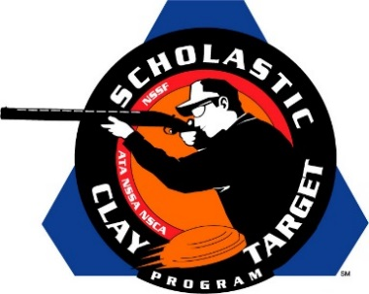

Iowa’s Spartan Trapshooting Takes Junior Varsity Division Handicap Trap National Title

SAN ANTONIO, Texas – The Spartan Trapshooting Team from Solon, Iowa, captured the Junior Varsity Division title in Handicap Trap at the Scholastic Clay Target Program (SCTP) National Team Championships breaking 741 of their 1,000 targets.

Held July 13-18 at the World Shooting and Recreational Complex in Sparta, Illinois, 2,466 athletes faced over 872,500 clay targets during six days of competition in the shooting disciplines for Trap, Skeet and Sporting Clays.

The Spartan squad was led by Jarrett Manifold (Solon) who broke 159 targets with Michael Baumgartner (Solon) adding another 157. Chase Gehrke (Solon) with 144, Christian Haight (Ely) with 142 and Nicole Breese (Solon) with 139 secured the team’s status as the 2015 National Champions.

Wisconsin’s Langlade County Falcons finished second. The squad of five from Antigo combined for 686 total targets with Adam Hilger leading (170) followed by Casey Hefner (165), Casey Lucas (132), Jordan Marvin (116) and Matt Young (103).

Another Iowa team, the Clear Creek Amana High School Trap squad, placed third with Riley Pirkl (Tiffin) breaking 165 targets, Chris Herring (Homestead) with 144, Garret Wetjen (Homestead) with 124, Tyne Simmons (North Liberty) with 118 and Nicole Cullen (Tiffin) with 113 combining for a total of 664.

The Scholastic Clay Target Program (SCTP) is a youth development program in which adult coaches and other volunteers use the shooting sports of Trap, Skeet and Sporting Clays, as well as the Olympic disciplines of Bunker Trap, Trap Doubles and International Skeet to teach and to demonstrate sportsmanship, responsibility, honesty, ethics, integrity, teamwork, and other positive life skills.

The Scholastic Shooting Sports Foundation, Inc. (SSSF), a 501(c)(3) nonprofit organization, is the National Governing Body for the Scholastic Clay Target Program. SCTP was started by the National Shooting Sports Foundation in 2001.

For more information about SCTP and SSSF, visit www.sssfonline.org. You can also follow SCTP on Facebook at www.facebook.com/ShootSCTP.

