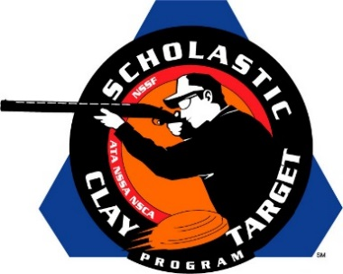

Ben Avery Clay Crushers Score Intermediate/Advanced Division Handicap Trap National Title

SAN ANTONIO, Texas – Arizona’s Ben Avery Clay Crushers outpaced Wisconsin’s Central Falcons by 53 targets to take the Intermediate/Advanced Level Division title in Handicap Trap competition at the Scholastic Clay Target Program (SCTP) National Team Championships.

Held July 13-18 at the World Shooting and Recreational Complex in Sparta, Illinois, 2,466 athletes faced over 872,500 clay targets during six days of competition in the shooting disciplines for Trap, Skeet and Sporting Clays.

The Ben Avery squad was led by Eric Zingg of Glendale breaking 182 of 200 targets, followed by Victoria Hendrix (Glendale) with 163, Alex Pieraccini (Phoenix) with 160, Chase Jones (Phoenix) with 160 and Brook Taylor (Surprise) with 147.

Robert Rauhut of Ringwood, Ill. and Gene Bacsa IV of Ingleside, Ill. were the top guns for the Central Falcons squad with each breaking 168 targets. Zachary Hanson (Bristol, Wisc.) followed with 161 while Kenneth Beverley (Ingleside, Ill.) and Matthew Knapp (Pleasant Prairie, Wisc.) added 160 and 102 targets respectively.

The Scholastic Clay Target Program (SCTP) is a youth development program in which adult coaches and other volunteers use the shooting sports of Trap, Skeet and Sporting Clays, as well as the Olympic disciplines of Bunker Trap, Trap Doubles and International Skeet to teach and to demonstrate sportsmanship, responsibility, honesty, ethics, integrity, teamwork, and other positive life skills.

The Scholastic Shooting Sports Foundation, Inc. (SSSF), a 501(c)(3) nonprofit organization, is the National Governing Body for the Scholastic Clay Target Program. SCTP was started by the National Shooting Sports Foundation in 2001.

For more information about SCTP and SSSF, visit www.sssfonline.org. You can also follow SCTP on Facebook at www.facebook.com/ShootSCTP.

