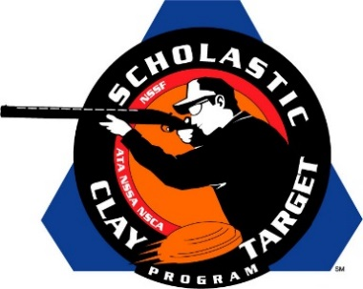

Missouri’s Wildcat Trap Grabs 2nd SCTP National Title, In Doubles Trap

SAN ANTONIO, Texas – After taking the Varsity Division national title in Handicap Trap, Missouri’s Wildcat Trap Team returned to the podium for a second title, this time in Doubles Trap, after breaking 875 of 1,000 targets during the Scholastic Clay Target Program (SCTP) 2015 National Team Championships.

Held July 13-18 at the World Shooting and Recreational Complex in Sparta, Illinois, 2,466 athletes faced over 872,500 clay targets during six days of competition in the shooting disciplines for Trap, Skeet and Sporting Clays.

The Wildcats were led by Chase Jacopian of Rogersville who was the High Overall shooter within the division with 190 targets broken. Joshua Galloway (Fordland) finished with 175 followed by Caleb Miller (Rogersville) 172, Ethan Boyer (Rogersville) with 170 and Cole Perry (Rogersville) with 168

Second place in the division went to the Maquoketa Cardinals from Iowa. Samuel Fowler (Maquoketa) and Dylan Schepers (Delmar) led their squad with each breaking 180 targets. Lane Dundee (Maquoketa) with 178, Kolton Manning (Maquoketa) with 171 and Lance Miller (Baldwin) with 156 helped the squad finish with a total of 865.

Taking third place in their bid for the national title was the Bolton Trap Team Varsity Silver squad from Tennessee. Colton Nation and Zach McClung, both of Bartlett, led the squad with 170 targets each. Garrett Percer (Millington) and Peyton Dean (Arlington) with 169 each, along with Griffin Black (Bartlett) with 168, helped the Volunteer State shooters break a total of 846 targets.

The Scholastic Clay Target Program (SCTP) is a youth development program in which adult coaches and other volunteers use the shooting sports of Trap, Skeet and Sporting Clays, as well as the Olympic disciplines of Bunker Trap, Trap Doubles and International Skeet to teach and to demonstrate sportsmanship, responsibility, honesty, ethics, integrity, teamwork, and other positive life skills.

The Scholastic Shooting Sports Foundation, Inc. (SSSF), a 501(c)(3) nonprofit organization, is the National Governing Body for the Scholastic Clay Target Program. SCTP was started by the National Shooting Sports Foundation in 2001.

For more information about SCTP and SSSF, visit www.sssfonline.org. You can also follow SCTP on Facebook at www.facebook.com/ShootSCTP.

