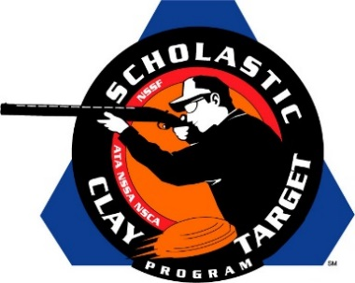

**Top Guns For Men’s And Women’s Doubles Trap Named At SCTP Nationals**

SAN ANTONIO, Texas – The top male and female athletes in Doubles Trap were recognized by the Scholastic Clay Target Program (SCTP) at the 2015 National Team Championships for their outstanding individual performances in each of its six competitive divisions.

Honored for their ability to break clay targets on the Handicap Trap fields at the SCTP Nationals were women shooters Ella Kurrus (Kirkwood, Mo.) of Team Henges in the Rookie Division who broke 140 targets; Dakota Duke (Charlotte, Tenn.) of the Dickson Clay Commanders in the Intermediate/Entry Level Division with 146; Madeline VanderSchaaf (Mayville, Wisc.) of the Flyway Clay Slayers in the Intermediate/Advanced Division with 161; Nicole Breese (Solon, Iowa) on the Spartan Trapshooting Team in the Junior Varsity Division with 166; Jordan Osborne (Lynnville, Tenn.) of the Richland Trap & Sporting Clays in the Varsity Division with 184; and Brandy Napoli (La Crescenta, Calif.) of the California Junior Claybreakers in the Collegiate Division with 177.

Among the men competing this year the top performances came from Grant Weiler (Ste Genevieve, Mo.) of the Arnold Junior Shooters in the Rookie Division with 119; Chase Perry (Rogersville, Mo.) of the Wildcat Trap Team in the Intermediate/Entry Level Division with 167; Alex York (Lanark, Ill.) of the YSSA Orange Crushers in the Intermediate/Advanced Division with 184; Mathew Wells (Beaver Dam, Wisc.) of the Beaver Dam Golden Beavers in the Junior Varsity Division with 184; Chase Jacopian (Rogersville, Mo.) of the Wildcat Trap Team in the Varsity Division with 190; and Jordan Hintz (Burlington, Wisc.) of the B.H.S. Demons Shooting Team in the Collegiate Division with 195.

Held July 13-18 at the World Shooting and Recreational Complex in Sparta, Illinois, 2,466 athletes faced over 872,500 clay targets during six days of competition in the shooting disciplines for Trap, Skeet and Sporting Clays.

The Scholastic Clay Target Program (SCTP) is a youth development program in which adult coaches and other volunteers use the shooting sports of Trap, Skeet and Sporting Clays, as well as the Olympic disciplines of Bunker Trap, Trap Doubles and International Skeet to teach and to demonstrate sportsmanship, responsibility, honesty, ethics, integrity, teamwork, and other positive life skills.

The Scholastic Shooting Sports Foundation, Inc. (SSSF), a 501(c)(3) nonprofit organization, is the National Governing Body for the Scholastic Clay Target Program. SCTP was started by the National Shooting Sports Foundation in 2001.

For more information about SCTP and SSSF, visit [www.sssfonline.org](http://www.sssfonline.org). You can also follow SCTP on Facebook at www.facebook.com/ShootSCTP.