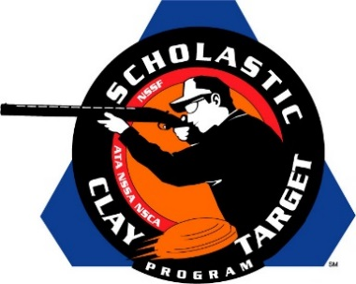

Iowa’s Spartan Trapshooting Takes Junior Varsity Division Doubles Trap National Title

SAN ANTONIO, Texas – Following up on their national title win in Handicap Trap, the Spartan Trapshooting Team from Solon, Iowa, captured the Junior Varsity Division title in Doubles Trap by breaking 762 of their 1,000 targets during the the Scholastic Clay Target Program (SCTP) National Team Championships.

Held July 13-18 at the World Shooting and Recreational Complex in Sparta, Illinois, 2,466 athletes faced over 872,500 clay targets during six days of competition in the shooting disciplines for Trap, Skeet and Sporting Clays.

The Spartan squad was led by Nicole Breese of Solon who broke 166 of her 200 targets, followed by Michael Baumgartner (Solon) with 162, Christian Haight (Ely) with 160, Chase Gehrke (Solon) with 146 and Jarrett Manifold (Solon) with 128.

Finishing second in the division were the Rio Salado Target Terminators of Arizona who broke a combined 621 targets. Cory Glon of Gilbert led with a team high of 159 followed by Mathew Campbell (Gilbert) WITH 123, Tucker Siddoway (Gilbert) with 117, Stephen Matter (Mesa) with 114 and Jared Costello of (Gilbert) with 108.

The Scholastic Clay Target Program (SCTP) is a youth development program in which adult coaches and other volunteers use the shooting sports of Trap, Skeet and Sporting Clays, as well as the Olympic disciplines of Bunker Trap, Trap Doubles and International Skeet to teach and to demonstrate sportsmanship, responsibility, honesty, ethics, integrity, teamwork, and other positive life skills.

The Scholastic Shooting Sports Foundation, Inc. (SSSF), a 501(c)(3) nonprofit organization, is the National Governing Body for the Scholastic Clay Target Program. SCTP was started by the National Shooting Sports Foundation in 2001.

For more information about SCTP and SSSF, visit www.sssfonline.org. You can also follow SCTP on Facebook at www.facebook.com/ShootSCTP.

