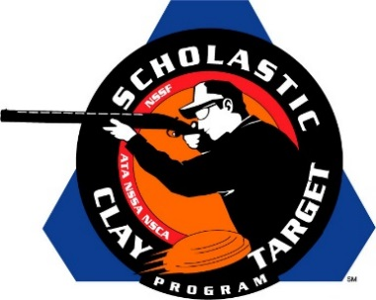

Wisconsin’s Central Falcons Win Intermediate/Advanced Division Doubles Trap National Title

SAN ANTONIO, Texas – By just 34 targets, Wisconsin’s Central Falcons outpaced Arizona’s Ben Avery Clay Crushers to take the Intermediate/Advanced Level Division title in Doubles Trap competition at the Scholastic Clay Target Program (SCTP) National Team Championships.

Held July 13-18 at the World Shooting and Recreational Complex in Sparta, Illinois, 2,466 athletes faced over 872,500 clay targets during six days of competition in the shooting disciplines for Trap, Skeet and Sporting Clays.

Breaking 172 of his 200 targets, Zachary Hanson (Bristol, Wisc.) led the Central Falcons to the title, followed by Robert Rauhut (Ringwood, Ill.) with 162, Kenneth Beverley (Ingleside, Ill.) with 154, Gene Bacsa IV (Ingleside, Ill.) with 123 and Colby Nikula (Bristol, Wisc.) with 105.

Victoria Hendrix of Glendale led her Ben Avery Clay Crushers squad with 152 targets followed by Eric Zingg (Glendale) with 148, Chase Jones (Phoenix) with 140, Alex Pieraccini (Phoenix) with 125 and Brook Taylor (Surprise) with 117.

The Scholastic Clay Target Program (SCTP) is a youth development program in which adult coaches and other volunteers use the shooting sports of Trap, Skeet and Sporting Clays, as well as the Olympic disciplines of Bunker Trap, Trap Doubles and International Skeet to teach and to demonstrate sportsmanship, responsibility, honesty, ethics, integrity, teamwork, and other positive life skills.

The Scholastic Shooting Sports Foundation, Inc. (SSSF), a 501(c)(3) nonprofit organization, is the National Governing Body for the Scholastic Clay Target Program. SCTP was started by the National Shooting Sports Foundation in 2001.

For more information about SCTP and SSSF, visit www.sssfonline.org. You can also follow SCTP on Facebook at www.facebook.com/ShootSCTP.

