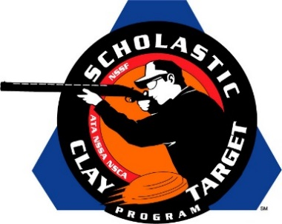

Tennessee’s Haywood Young Guns Claim Varsity Division Doubles Skeet National Title

SAN ANTONIO, Texas – Led by the the high overall shooter in Doubles Skeet, the Haywood Young Guns of Tennessee claimed the Varsity Division Doubles Skeet title at the Scholastic Clay Target Program (SCTP) National Team Championships.

Zachary Tinsley of Bells dropped just one of his 100 targets while leading his Haywood Young Guns teammates Ford Ellington (Brownsville) with 92 and Michael Hunter Campbell (Somerville) with 91 to a combined 282 and the national title.

Held July 13-18 at the World Shooting and Recreational Complex in Sparta, Illinois, 2,466 athletes faced over 872,500 clay targets during six days of competition in the shooting disciplines for Trap, Skeet and Sporting Clays.

Second place in Doubles Skeet went to another Volunteer State team, the Montgomery County Youth Shooting Sports Bad Habit which finished breaking 277 of 300 targets. Michael Johnson (Southside) led the squad with 93, followed by Trace Crockett (Palmyra) and Ben Smith (Clarksville), each with 92.

Arizona’s Ben Avery Clay Crushers Varsity Blue squad took third in the division with Casey Coleman (Glendale) with 93, Lucas Pieraccini (Phoenix) with 90 and Noah Overbey (Glendale) with 84 combining for a total of 267

The Scholastic Clay Target Program (SCTP) is a youth development program in which adult coaches and other volunteers use the shooting sports of Trap, Skeet and Sporting Clays, as well as the Olympic disciplines of Bunker Trap, Trap Doubles and International Skeet to teach and to demonstrate sportsmanship, responsibility, honesty, ethics, integrity, teamwork, and other positive life skills.

The Scholastic Shooting Sports Foundation, Inc. (SSSF), a 501(c)(3) nonprofit organization, is the National Governing Body for the Scholastic Clay Target Program. SCTP was started by the National Shooting Sports Foundation in 2001.

For more information about SCTP and SSSF, visit www.sssfonline.org. You can also follow SCTP on Facebook at www.facebook.com/ShootSCTP.

