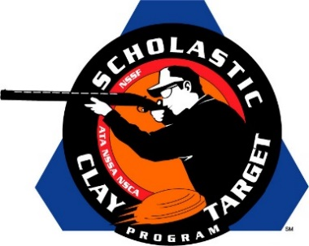

Top Guns For Men’s And Women’s Doubles Skeet Named At SCTP Nationals

SAN ANTONIO, Texas – The top male and female athletes were recognized by the Scholastic Clay Target Program (SCTP) at the 2015 National Team Championships for their outstanding individual performances in each of its six competitive divisions.

Honored for their ability to break clay targets on the Doubles Skeet fields at the SCTP Nationals were women shooters Emily Shedd (Eloy, Ariz.) of the Central Arizona Target Shooters in the Rookie Division with 63; Dakota Duke (Charlotte, Tenn.) of the Dickson Clay Commanders in the Intermediate/Entry Level Division with 78; Camryn McCraney (Buford, Ga.) of the Etowah Valley Mambas in the Intermediate/Advanced Division with 83; Alexis Eidson (Byron, Ga.) of the Brookline Top Shots in the Junior Varsity Division with 96; Lindsay Martin (Glen Allen, Va.) of the Ft. Lee Dusters in the Varsity Division with 92; and Jordan Lane (Madison, Ga.) of the Lake Oconee Shotgun Team in the Collegiate Division with 95.

Among the men competing this year the top performances came from Sheaffer Stanfill (Clarksville, Tenn.) of the Montgomery County Youth Shooting Sports in the Rookie Division with 79; Cole Gintert (Morrow, Ohio) of the Fairfield Sportsmen's Lead Slingers in the Intermediate/Entry Level Division with 91; Aaron Copelan (Eatonton, Ga.) of the Lake Oconee Shotgun Team in the Intermediate/Advanced Division with 98; Jonathan Vandiver (Jackson, Tenn.) of the Haywood Young Guns in the Junior Varsity Division with 94; Zachary Tinsley (Bells, Tenn.) of the Haywood Young Guns in the Varsity Division with 99; and Mark Beardsley (Glen Rock, Pa.) of the Emmanuel College Clay Target Shooting in the Collegiate Division with 93.

Held July 13-18 at the World Shooting and Recreational Complex in Sparta, Illinois, 2,466 athletes faced over 872,500 clay targets during six days of competition in the shooting disciplines for Trap, Skeet and Sporting Clays.

The Scholastic Clay Target Program (SCTP) is a youth development program in which adult coaches and other volunteers use the shooting sports of Trap, Skeet and Sporting Clays, as well as the Olympic disciplines of Bunker Trap, Trap Doubles and International Skeet to teach and to demonstrate sportsmanship, responsibility, honesty, ethics, integrity, teamwork, and other positive life skills.

The Scholastic Shooting Sports Foundation, Inc. (SSSF), a 501(c)(3) nonprofit organization, is the National Governing Body for the Scholastic Clay Target Program. SCTP was started by the National Shooting Sports Foundation in 2001.

For more information about SCTP and SSSF, visit www.sssfonline.org. You can also follow SCTP on Facebook at www.facebook.com/ShootSCTP.

