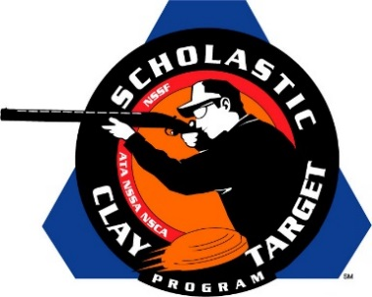

Virginia’s Ft. Lee Dusters Take Junior Varsity Division Doubles Skeet National Title

SAN ANTONIO, Texas – The Ft. Lee Dusters of Virginia outpaced squads from Tennessee and Georgia to take the Junior Varsity Division title in Doubles Skeet by breaking 276 of their 300 targets during the Scholastic Clay Target Program (SCTP) National Team Championships.

Held July 13-18 at the World Shooting and Recreational Complex in Sparta, Illinois, 2,466 athletes faced over 872,500 clay targets during six days of competition in the shooting disciplines for Trap, Skeet and Sporting Clays.

The Ft. Lee Dusters were led by Zachary Wells (Blackstone) with 94, followed by Logan R. Whitley (Suffolk) with 94 and Hunter Belch (Suffolk) with 88.

Second place went to the Haywood Young Guns from Tennessee who posted a final of 267 targets. Jonathan Vandiver (Jackson) led the squad with 94, with Tritt Ellington (Brownsville) and Blake Robinson (Huron) adding 88 and 85 targets respectively.

Georgia’s Brookline Top Shots rounded out the top three with Alexis Eidson (Byron) with 96, Kevin Bandt (Fort Valley) with 89 and Chase Crutchfield (Round Oak) with 80 combining for a third place finish of 265 targets.

The Scholastic Clay Target Program (SCTP) is a youth development program in which adult coaches and other volunteers use the shooting sports of Trap, Skeet and Sporting Clays, as well as the Olympic disciplines of Bunker Trap, Trap Doubles and International Skeet to teach and to demonstrate sportsmanship, responsibility, honesty, ethics, integrity, teamwork, and other positive life skills.

The Scholastic Shooting Sports Foundation, Inc. (SSSF), a 501(c)(3) nonprofit organization, is the National Governing Body for the Scholastic Clay Target Program. SCTP was started by the National Shooting Sports Foundation in 2001.

For more information about SCTP and SSSF, visit www.sssfonline.org. You can also follow SCTP on Facebook at www.facebook.com/ShootSCTP.

