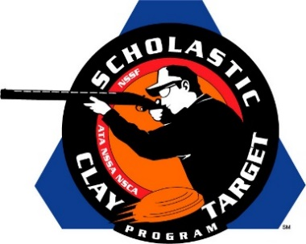

Arizona’s Ben Avery Clay Crushers Capture Intermediate/Entry Level Division Doubles Skeet National Title

SAN ANTONIO, Texas – The Ben Avery Clay Crushers of Arizona, which finished fifth in Sporting Clays, held off squads from Montana and Tennessee to take home the Intermediate/Entry Level Division title in Doubles Skeet at the Scholastic Clay Target Program (SCTP) National Team Championships.

Held July 13-18 at the World Shooting and Recreational Complex in Sparta, Illinois, 2,466 athletes faced over 872,500 clay targets during six days of competition in the shooting disciplines for Trap, Skeet and Sporting Clays.

Victor Cordova of Cave Creek, Griffin Toliver of Phoenix and Christopher Welsh of Peoria combined to break a total of 251 of 300 targets, and claim the national title, shooting 89, 84 and 78 respectively.

Second place went to the Smokin Guns of Montana with 235. Keagan Crowley (Laurel) led with 82 followed by Preston Bailey (Columbus) with 78 and Connor Bergman (Laurel) with 75.

The Clarksville High Shooting Sports Team of Tennessee finished third in Doubles Skeet breaking 222 of their 300 targets. Elijah McGaha led the team with 86, with Hunter Crosby adding 69 and Cameron Durrett another 67. All three athletes are from Clarksville.

The Scholastic Clay Target Program (SCTP) is a youth development program in which adult coaches and other volunteers use the shooting sports of Trap, Skeet and Sporting Clays, as well as the Olympic disciplines of Bunker Trap, Trap Doubles and International Skeet to teach and to demonstrate sportsmanship, responsibility, honesty, ethics, integrity, teamwork, and other positive life skills.

The Scholastic Shooting Sports Foundation, Inc. (SSSF), a 501(c)(3) nonprofit organization, is the National Governing Body for the Scholastic Clay Target Program. SCTP was started by the National Shooting Sports Foundation in 2001.

For more information about SCTP and SSSF, visit www.sssfonline.org. You can also follow SCTP on Facebook at www.facebook.com/ShootSCTP.

