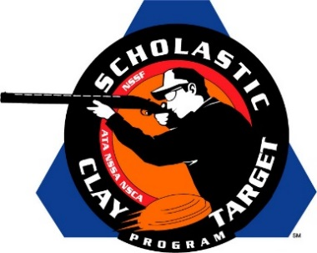

Southern Shooting Sports (Tenn.) Wins Intermediate/Advanced Division Doubles Skeet National Title

SAN ANTONIO, Texas – The Volunteer State’s Southern Shooting Sports squad of Austin Brown (Cumberland City), Ely Weakley (Ashland City) and Tyler Byard (Clarksville) broke a combined 247 of 300 targets to win the Intermediate/Advanced Division title in Doubles Skeet at the Scholastic Clay Target Program (SCTP) National Team Championships.

Austin Brown led Southern Shooting Sports with 85 followed by Ely Weakley with 84 and Tyler Byard with 78.

Held July 13-18 at the World Shooting and Recreational Complex in Sparta, Illinois, 2,466 athletes faced over 872,500 clay targets during six days of competition in the shooting disciplines for Trap, Skeet and Sporting Clays.

Second place went to Iowa’s Oskaloosa Shooting Team. A trio of Oskaloosa shooters, Aaron Vos with 83, Joseph Heimroth with 80 and Colin Fiechtner with 76, combined for a total of 239.

Tennessee’s McKenzie Shooting Sports finished third just two targets back of Oskaloosa with 237. Will McBride (McKenzie) led the squad with 87 followed by Chase Colotta (Gleason) with 78 and Drew Beeler (McKenzie) with 72.

The Scholastic Clay Target Program (SCTP) is a youth development program in which adult coaches and other volunteers use the shooting sports of Trap, Skeet and Sporting Clays, as well as the Olympic disciplines of Bunker Trap, Trap Doubles and International Skeet to teach and to demonstrate sportsmanship, responsibility, honesty, ethics, integrity, teamwork, and other positive life skills.

The Scholastic Shooting Sports Foundation, Inc. (SSSF), a 501(c)(3) nonprofit organization, is the National Governing Body for the Scholastic Clay Target Program. SCTP was started by the National Shooting Sports Foundation in 2001.

For more information about SCTP and SSSF, visit www.sssfonline.org. You can also follow SCTP on Facebook at www.facebook.com/ShootSCTP.

